**ENABLING ENHANCED PATIENT CARE AIDED BY ARTIFICIAL INTELLIGENCE-**

**HEALTHAI CONNECT**

Project Report Submitted

In Partial Fulfillment of the Requirements

For The Degree of

**BACHELOR OF ENGINEERING**

**IN**

**INFORMATION TECHNOLOGY**

Submitted By

|  |  |
| --- | --- |
| **Abdul Rahman Hussain Siddique** | **(1604-20-737-084)** |
| **Syed Rahmath** | **(1604-20-737-095)** |
| **Omar Mohammed Khan** | **(1604-20-737-113)** |

Under the Guidance of

**Dr. MD Asrar Ahmed**

**(Assistant Professor)**

**DEPARTMENT OF INFORMATION TECHNOLOGY**

**MUFFAKHAM JAH COLLEGE OF ENGINEERING & TECHNOLOGY**

**(Affiliated to Osmania University)**

**Mount Pleasant, 8-2-249, Road No. 3, Banjara Hills, Hyderabad-34**

**2020-2024**



**CERTIFICATE**

It is certified that the work contained in the project report titled “**Enabling Enhanced Patient Care Aided by Artificial Intelligence - HealthAI Connect**,” by

|  |  |
| --- | --- |
| **Mr. ABDUL RAHMAN HUSSAIN SIDDIQUE** | **(1604-20-737-084)** |
| **Mr. SYED RAHMATH** | **(1604-20-737-095)** |
| **Mr. OMAR MOHAMMED KHAN** | **(1604-20-737-113)** |

has been carried out under my/our supervision and that this work has not been submitted

elsewhere for a degree

|  |  |
| --- | --- |
| Project Supervisor  **Dr. MD ASRAR AHMED**  Information Technology Dept.  MJ College of Engineering & Tech.  Hyderabad – 500 034. | Signature of Head  **HEAD, ITD**  Information Technology Dept.  MJ College of Engineering & Tech.  Hyderabad – 500 034 |

External Examiner

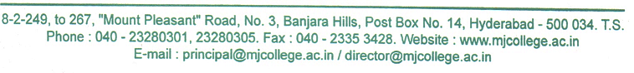

**DECLARATION**

We, **Abdul Rahman Hussain Siddique, Syed Rahmath,** **Omar Mohammed Khan** bearing Roll No.1604-20-737-084, 1604-20-737-095, 1604-20-737-113 respectively. Hereby declare that the project report entitled **“ENABLING ENHANCED PATIENT CARE AIDED BY ARITIFICIAL INTELLIGENCE-HEALTHAI CONNECT**” is done as major project during the Course work of BE (4/4) and is done under the guidance of, **Dr. MD. ASRAR AHMED,** Assistant Professor, Department of Information Technology, Muffakham Jah College of Engineering and Technology. This is a record of bonafide work carried out by us in Muffakham Jah College of Engineering & Technology and the results embodied in this project have not been reproduced or copied from any source.

**ABDUL RAHMAN HUSSAIN SIDDIQUE-(1604-20-737-084)**

**SYED RAHMATH-(1604-20-737-095)**

**OMAR MOHAMMED KHAN-(1604-20-737-113)**

**ACKNOWLEDGEMENT**

The austerity and satisfaction that one gets on completing a project cannot be fulfilled without mentioning the people who made it possible with gratitude.

We are grateful to the almighty God who helped us all the way throughout the project and also has molded us into what we are today. We express our sincere thanks to our parents who encouraged us always to achieve our goals.

We offer our sincere thanks to **MUFFAKHAM JAH COLLEGE OF ENGINEERING AND TECHNOLOGY** for allowing us to do our major project in their esteemed institution.

We show gratitude to the **DR. MAHIPAL SINGH RAWAT** (Principal) for having provided all the facilities and support. We would like to thank **HEAD ITD**, (Head of the Department, Information Technology Department) for her expert guidance and encouragement at various level of project.

We are Thankful to our guide **Dr. MD. ASRAR AHMED** (Assistant Professor, Information Technology Department) for his sustained inspiring guidance and cooperation throughout the process of this project report.

We express our deep sense of gratitude and thanks to all the Teaching and Non-Teaching Staff of our college who stood with us and helped us to make it a successful venture.

**ABDUL RAHMAN HUSSAIN SIDDIQUE-(1604-20-737-084)**

**SYED RAHMATH-(1604-20-737-095)**

**OMAR MOHAMMED KHAN-(1604-20-737-113)**

**ABSTRACT**

In the rapidly advancing technological era, Artificial Intelligence (AI) has transformed healthcare, reshaping patient care and diagnosis. Our thesis delves into AI and Machine Learning's crucial role in improving healthcare through 'HealthAI Connect,' a platform leveraging AI for personalized patient guidance, predictive analytics, and enhanced accessibility to healthcare. This platform employs AI to provide personalized guidance for specific health issues and clever predictions based on symptoms or health descriptions. The proposed platform features a medical chatbot, which aids in smart decision-making and addressing health queries. We introduced dashboards for both patients and doctors within HealthAI Connect. The dashboard streamlines features tailored to each user type. For patients, the dashboard offers easy appointment scheduling and personalized health recommendations. Patients can also engage in online consultations with doctors via web chat, enhancing accessibility and convenience. For doctors, the dashboard offers key performance indicators displaying appointment details. Moreover, doctors can use the dashboard to track tasks and make informed decisions with the help of the Medical Chatbot. By integrating these features, HealthAI Connect aims to make healthcare smoother and more accessible, empowering patients to manage their health. Furthermore, HealthAI Connect leverages advanced technology to detect fatal diseases such as brain tumors and pneumonia early, emphasizing the importance of early detection for prompt intervention. We conclude with a comprehensive overview of HealthAI Connect's potential impact on healthcare delivery, emphasizing its role in fostering proactive patient engagement, improving clinical outcomes, and ultimately, shaping a more efficient and patient-centric healthcare ecosystem.

**CONTENTS**

1. **INTRODUCTION..............................................................................................................1**

1.1 Problem Statement...................................................................................................2

1.2 Project Purpose........................................................................................................2

1.3 Project Scope….......................................................................................................3

**2. LITERATURE SURVEY.....................................................................................................5**

**3. SYSTEM ANALYSIS...........................................................................................................8**

3.1 Problems with Existing System..............................................................................8

3.2 Proposed System...................................................................................................10

3.2.1 Features..................................................................................................10

3.2.2 Proposed System Advantages................................................................11

3.3 Technology Used..................................................................................................11

3.3.1 Backend..................................................................................................11

3.3.2 Frontend..................................................................................................15

3.4 System Requirements............................................................................................17

3.4.1 Hardware Requirements.........................................................................17

3.4.2 Software Requirements..........................................................................17

**4. SYSTEM DESIGN.............................................................................................................18**

4.1 Systems Architecture............................................................................................18

4.2 Subsystems Architecture.......................................................................................19

4.2.1 Health Description Disease Predictor....................................................19

4.2.2 Symptoms-based Disease Predictor.......................................................20

4.2.3 RAG Medical Chatbot............................................................................21

4.2.4 Appointment Booking System and Webchat Consultation....................21

4.2.5 Brain Tumor Detection..........................................................................22

4.2.6 Pneumonia Detection.............................................................................23

4.2.7 NutriVision.............................................................................................23

4.2.8 Process Flow and Input/Output format..................................................24

**5. IMPLEMENTATION........................................................................................................25**

5.1 Health Description Disease Predictor...................................................................25

5.1.1 Data Collection.......................................................................................25

5.1.2 Preprocessing.........................................................................................26

5.1.3 Machine Learning..................................................................................27

5.1.4 Training..................................................................................................31

5.2 Symptoms-based Disease Predictor......................................................................33

5.2.1 Data Collection.......................................................................................33

5.2.2 Preprocessing.........................................................................................33

5.2.3 Decision Tree.........................................................................................34

5.2.4 Random Forest.......................................................................................35

5.2.5 Training..................................................................................................37

5.3 Pneumonia Detection............................................................................................38

5.3.1 Data Collection.......................................................................................38

5.3.2 CNN and VGG-16..................................................................................39

5.3.3 Training..................................................................................................40

5.4 Brain Tumor Detection.........................................................................................41

5.4.1 Data Collection.......................................................................................42

5.4.2 Preprocessing.........................................................................................42

5.4.3 CNN.......................................................................................................42

5.4.4 Training..................................................................................................44

5.5 RAG Medical Chatbot..........................................................................................45

5.6 NutriVision...........................................................................................................48

5.7 Appointment Booking System and Webchat Consultation..................................49

5.8 Libraries Used.......................................................................................................50

**6. SCREENSHOTS................................................................................................................52**

**7. TEST CASES......................................................................................................................61**

**8. CONCLUSION...................................................................................................................62**

**9. REFERENCES...................................................................................................................63**

**APPENDIX I**...........................................................................................................................**65**

**APPENDIX II**.........................................................................................................................**67**

**LIST OF FIGURES**

|  |  |  |
| --- | --- | --- |
| **Figure No.** | **Figure Name** | **Page No.** |
| 4.1 | System Architecture | 18 |
| 4.2.1 | Health Description based Disease Predictor Architecture | 19 |
| 4.2.2 | Symptoms based Disease Predictor Architecture | 20 |
| 4.2.3 | RAG Medical Chatbot Architecture | 21 |
| 4.2.4 | Appointment booking system and Consultation Architecture | 21 |
| 4.2.5 | Brain Tumour Detector Architecture | 22 |
| 4.2.6. | Pneumonia Detector Architecture | 23 |
| 4.2.7 | NutriVision Architecture | 23 |
| 4.3 | Process Flow and Input/Output Formats | 24 |
| 5.1.2 | Word Cloud for Depression | 26 |
| 5.1.3 (a) | A Graphical Illustration of a Naive Bayes Classifier | 28 |
| 5.1.3 (b) | Bayes Theorem | 29 |
| 5.1.3 (c) | Illustration of Passive & Aggressive | 20 |
| 5.1.4 | Confusion Matrix of PAC | 32 |
| 5.2.2 | Dataset information | 34 |
| 5.2.3 | Key Components of Decision Tree | 35 |
| 5.2.3 | Machine Learning Process of Random Forest | 36 |
| 5.2.5 (a) | Performance of Random Forest on Disease Prediction | 37 |
| 5.2.5 (b) | Comparison of Algorithm Accuracies | 38 |
| 5.3.2 (a) | VGG16 Convolutional Neural Network Architecture | 40 |
| 5.3.2 (b) | Layers of the VGG-16 network | 40 |
| 5.4.3 (a) | Convolutional Neural Network Process | 43 |
| 5.4.3 (b) | Understanding Convolutional Neural Networks | 44 |
| 5.4.4 | Training Log of a Deep Learning Model | 45 |
| 5.5 | Process of Retrieval Augmented Generation (RAG) | 46 |
| 6.1 | Homepage | 52 |
| 6.2 | Project Feature showcase cards | 52 |
| 6.3 | Register and Login Pages | 53 |
| 6.4 | RAG Medical Chatbot | 53 |
| 6.5 | Patient Dashboard | 54 |
| 6.6 | Doctor Dashboard | 55 |
| 6.7 | Symptoms Based Disease Predictor | 56 |
| 6.8 | Web Chat System | 56 |
| 6.9 | Health Condition Description Disease Predictor | 57 |
| 6.10 | Health Imaging Page | 57 |
| 6.11 (a) | Pneumonia Detection Page | 58 |
| 6.11 (b) | Pneumonia Detection Page | 58 |
| 6.12.(a) | Brain Tumor Detection Page | 59 |
| 6.12.(b) | Brain Tumor Detection Page | 59 |
| 6.13 (a) | NutriVision Page | 60 |
| 6.13 (b) | NutriVision Results | 60 |

1. **INTRODUCTION**

In an era where healthcare is swiftly embracing technological advancement, the integration of Artificial Intelligence stands out as a transformative force, reshaping the very essence of patient care. At the forefront of this revolution lies HealthAI Connect, an innovative platform designed to deliver personalized healthcare guidance through AI models and predictive analytics. It goes beyond the usual healthcare methods by using advance ML algorithms to improve how patients are cared for. It acts like a guide, offering information about diseases, medications, and precautions. The platform features a friendly chatbot, well-trained in medical knowledge. More than just an information source, this chatbot stands as a supportive guide, empowering you to navigate the complexities of well-being and make informed decisions for a safe future. This chatbot is like having a knowledgeable friend in your pocket. It engages users in a conversation-like manner, helping users feel more comfortable and supported in managing their health.

HealthAI Connect comes with advanced features like easy appointment scheduling and online doctor consultations via web chat. With these innovative features, the medical landscape undergoes a beautiful transformation. Complex processes become harmonious melodies, and accessing care becomes a smooth, empowering experience for every patient. This user-centric approach ensures patient satisfaction and empowers individuals to take control of their health.

With easy appointment scheduling and online doctor consultations, HealthAI Connect brings healthcare to your fingertips. This saves time and effort, making it convenient for individuals to connect with healthcare professionals when needed. HealthAI Connect includes advanced features such as early detection of fatal diseases like brain tumors and pneumonia. These features are crucial as they highlight the platform's commitment to identifying critical conditions promptly, emphasizing the importance of early intervention. This timely intervention can significantly impact treatment outcomes, underlining the importance of these advanced features.

In a nutshell, HealthAI Connect combines the power of AI and healthcare to make health information accessible, user-friendly, and informative. Its features not only enhance patient care but also empower individuals to actively manage their health. The platform's friendly chatbot and advanced features contribute to a smoother healthcare experience, making it an essential tool for those seeking reliable health guidance and services.

* 1. **Problem Statement**

Amidst rising healthcare complexities and demand for personalized care, traditional healthcare systems struggle to efficiently address individual needs, leading to fragmented care experiences and suboptimal outcomes. The pressing challenge lies in revolutionizing healthcare delivery by harnessing the power of Artificial Intelligence to provide seamless, personalized, and accessible healthcare solutions. HealthAI Connect endeavors to confront this challenge head-on by integrating cutting-edge AI technologies to optimize patient care, streamline processes, and empower users to navigate their health journey with confidence and efficiency.

* 1. **Project Purpose**

The purpose of HealthAI Connect is to redefine and elevate the standards of healthcare delivery through the integration of cutting-edge artificial intelligence. At its core, this pioneering online healthcare platform aims to revolutionize medical services by introducing a comprehensive suite of advanced features designed to enhance various facets of the healthcare ecosystem.

First and foremost, HealthAI Connect strives to improve patient care by leveraging predictive algorithms, symptom analysis, and text-based health condition assessments. The goal is to provide personalized and accurate healthcare guidance, tailoring recommendations to the unique needs of each individual. Through the seamless integration of these advanced technologies, the platform seeks to enhance the overall patient experience and contribute to better health outcomes.

The platform places a strong emphasis on transforming doctor-patient interactions. By incorporating a sophisticated Natural Language Processing (NLP)-driven chatbot with extensive medical knowledge, HealthAI Connect facilitates easy access to healthcare information. This not only empowers users to make informed decisions about their health but also fosters a more engaged and proactive approach to wellness.

Additionally, HealthAI Connect addresses the logistical challenges in healthcare by offering a robust doctor appointment system and webchat functionalities. These features streamline communication between patients and healthcare professionals, promoting efficient scheduling and facilitating ongoing dialogue for a more patient-centric approach to care.

Looking towards the future, the platform harbors ambitious plans to incorporate healthcare imaging analysis, focusing on areas such as brain tumor and pneumonia detection. This forward-looking initiative underscores HealthAI Connect's commitment to staying at the forefront of technological advancements in healthcare, ultimately leading to more precise diagnostics and improved treatment strategies.

In summary, the purpose of HealthAI Connect is to pioneer a transformative shift in the healthcare landscape. By harnessing the power of AI, the platform aims to enhance patient care, redefine doctor-patient interactions, and contribute to the evolution of modern healthcare technology for the betterment of individuals and the healthcare industry as a whole.

* 1. **Project Scope**

HealthAI Connect represents a pioneering platform at the forefront of healthcare innovation, leveraging the power of Artificial Intelligence (AI) to transform patient care. Central to its mission is the delivery of personalized guidance, wherein AI techniques are harnessed to offer tailored advice for various health concerns. By empowering users with individualized insights, HealthAI Connect enables informed decision-making, enhancing the overall patient experience and promoting proactive health management.

One of the platform's standout features is its ability to facilitate rapid diagnosis and analytics. Through sophisticated machine learning algorithms, HealthAI Connect swiftly analyzes health condition descriptions or symptoms, expediting access to essential healthcare services and treatments. This capability not only saves valuable time but also contributes to improved patient outcomes by ensuring timely intervention.

Moreover, HealthAI Connect serves as a comprehensive information hub, furnishing users with detailed insights into diseases, medications, precautions, and treatment options. By enhancing users' understanding of their health conditions, the platform fosters a sense of empowerment and enables more informed healthcare decisions. This emphasis on education and awareness underscores HealthAI Connects commitment to promoting holistic health and wellness.

At the heart of HealthAI Connect lies its user-friendly chatbot interface, which engages users in conversation and provides support and guidance in managing health concerns. This accessible and intuitive interface facilitates seamless interaction with the platform, enhancing user engagement and satisfaction. Furthermore, the platform features an integrated appointment booking system, streamlining the process of scheduling appointments with healthcare professionals. This not only saves time and effort but also improves healthcare accessibility for patients and enhances operational efficiency for providers.

In addition, HealthAI Connect facilitates web chat consultations with healthcare professionals, enabling remote access to medical advice and guidance. This feature is particularly beneficial for individuals with mobility constraints or those residing in remote areas, expanding access to essential healthcare services. Furthermore, the platform incorporates advanced technology for early detection of fatal diseases such as brain tumors and pneumonia, underscoring its commitment to proactive health management and improved treatment outcomes.

In conclusion, HealthAI Connect represents a paradigm shift in patient-centric care, leveraging AI technology to enhance healthcare accessibility, efficiency, and outcomes. By prioritizing personalized guidance, rapid diagnosis, comprehensive information, and user-friendly interfaces, the platform aligns with corporate goals and business strategies while significantly improving the healthcare experience for all stakeholders.

1. **LITERATURE SURVEY**

Existing research on the healthcare using AI and ML has been everchanging. There have been a lot of improvement in AI technology for leveraging healthcare through unique and ingenious solutions. In this section we present a comprehensive review of existing state of the art in AI enabled healthcare systems.

**M. A. Khadija et al. [1]** shows that as all educational materials are provided as E-books which are easy to access and easy to study, but it will be uncomfortable for extended reading. They used GenAI approach to develop a chatbot that can answer the questions based on the provided PDF. They used LLM like OpenAI, Pinecone and also uses LangChain to generate response for the given query.

Another Author, **A. S et al. [2]** provided an NLP based multilingual conversational chatbot for providing remote healthcare consultation and education to patients especially in rural area. It can understand multiple languages and can provide appropriate response using text and as well as speech. It uses google dialog flow and other tools. It provides voice interface for illiterate users. This chatbot helps patients to get easy healthcare guidance and home remedy.

**S. Chakraborty et al. [3]** proposes a medical chatbot which uses deep learning for infectious disease prediction and prevention. The chatbot uses NLP to understand user queries and provide appropriate responses. It uses LSTM and Decision Tree algorithm. This chatbot is trained on a dataset containing info about disease, symptoms, treatment etc. It can handle text and voice inputs. It demonstrates a useful AI approach for developing medical chatbot.

In clinical data analysis, past studies have predominantly emphasized structured data, overlooking the valuable insights inherent in complementary text data. **M. Ehghaghi et al. [4]** aims to fill this gap by examining the importance of integrating text data in healthcare analytics. The idea is that extracting meaningful insights from clinical text in electronic health records (EHR) to predict diseases. The proposed algorithm uses clinical notes from the MIMIC-III dataset and combines text-based features which discovers a unique pattern. It identifies associations between clinical notes and diseases. The model gives a balance between interpretability and accuracy, offering insights from clinical text for predicting medical conditions.

The research by **Luo, Xiao et al. [5]** provides a deep language model which can extract patient-reported symptoms from clinical-text such as electronic health Records (EHR). The model integrates two types of analysis syntactic and semantic to identify symptoms from text which include conditional and negation expressions. It also performed well on three other advanced symptoms extraction models when tested on real world clinical text. The model highlights its effectiveness by analysing and demonstrating its application to extract COVID-19 symptoms from tweets, identifying symptoms early and even rare one suggested by CDC.

In today's world, online appointment systems are crucial, providing 24/7 accessibility, reducing physical interactions, optimizing time, streamlined scheduling and efficient resource utilization. **S. Usharani et al. [6]** proposes a mobile application for doctor appointment scheduling using Object Oriented Analysis and Design (OOAD) approach. It allows patients to select date and time for appointment. It also comprises an option for live video consultation with doctor. It uses android platform and cloud database.

The significance of disease prediction using AI lies in its potential to revolutionize healthcare by enabling early detection, proactive intervention, and personalized treatment plans**. U. K. Kommineni et al. [7]** showcases the study about different models used to predict disease and their differences over the accuracy, as nowadays the medical assistance requires time and money which aren’t always available to everyone so they can use this user-friendly GUI symptom-based disease predictor to get to know their health condition and not be unaware because of circumstances. This uses tkinter, Random Forest algorithm, Naive Bayes and uses appropriate data about the diseases from the hospital to get an accurate diagnosis.

**P. Hema et al. [8]** presents a ML Disease prediction system for quick and accurate analysis. It uses a dataset comprising of over 230 diseases, the authors implement various ML algorithms (11 algorithms), with weighted KNN yielding the highest accuracy i.e. 93.5%. It emphasizes the importance of a ML based developed system in early disease diagnosis, which may play a crucial role in emergency situations.

**K. S. Kumar et al. [9]** presents a Disease prediction system using an ML model (Random Forest) and a Python GUI (Tkinter). Users receive disease predictions from a hospital dataset using symptoms as inputs, emphasizing the handy and easy-to-get predictions. The study of patient records management challenges through Big Data Analytics shows a great use of ML in healthcare.

The integration of AI into health condition image detection through X-ray for diseases like brain tumors and pneumonia is crucial for rapid and precise diagnostics. **T. Nag et al. [10]** showcases about pneumonia detection. Pneumonia can be caused by various organisms and affects people differently with severe cases being life-threatening, especially for kids, the elderly, or those with health issues. The paper focuses on machine learning and specially a convolutional neural network (CNN), to predict pneumonia from X-ray images. It goes through the method used for analysis and discusses the accuracy of the model using a Confusion Matrix. The goal of the paper is to improve early detection of pneumonia using technology.

The research paper by **N. M. Dipu et al. [11]** focuses on early brain tumour detection using MRI scans. It uses two different methods; the first method uses YOLO (You Only Look Once) an object detection technique which achieves an accuracy of 85.95%. The second method uses FastAi, a deep learning library used for classification purposes which acquires 95.78% accuracy. The model is tested on a subset of the BRATS 2018 dataset, which can be applied in real time for early detection of brain tumour, assisting neurologists and radiologists in diagnosing brain tumour.

**A. Goswami et al. [12]** discusses about the role of MRI scans in diagnosis and brain tumours study. The MRI images helps to identify abnormal tissue growth or blood blocks in nervous system. The diagnostic process involves examining the brain structure for abnormalities and then using segmentation based on morphological operations, specifically fuzzy transformation. The paper explores various method for brain tumour segmentation and MRI image identification. It also considers the parameters like configuration, form, dimensions, and image position for feature extraction, leading to the classification of tumours.

1. **SYSTEM ANALYSIS**

In this section we present the comparison of above studied schemes with respect to the key strategy followed therein, the limitations of the schemes, and advantages of our proposed HealthAI Connect over these schemes. The Table 1 summarizes these findings.

**3.1 Problems with Existing System**

Table 1: Comparison of existing strategies and our proposed system

| Research Paper Title | Strategy | Limitation | Proposed System Advantage |
| --- | --- | --- | --- |
| Automating Information Retrieval from Faculty Guidelines: Designing a PDF-Driven Chatbot powered by OpenAI ChatGPT [1] | Uses GEN-AI approach, OpenAI, Langchain and Pinecone to generate response for the given query using LLM | Difficulty with long-form content, Lack of personalization, Data preprocessing time. | The rapid response time is attributed to using pre-existing word embeddings. |
| Dynamic NLP Enabled Chatbot for Rural Health Care in India [2] | Uses Google dialog flow software for NLP | Limited internet connectivity | Multilingual NLP Models |
| An AI-Based Medical Chatbot Model for Infectious Disease Prediction, [3] | Uses NLP, LSTM, Decision tree and RNN | Limited understanding of context, limited information Generalization Issues | Large knowledge base is used |
| Interpretable Disease Prediction from Clinical Text by Leveraging Pattern Disentanglement, [4] | Feature Extraction (TFIDF) and Pattern Discovery and Disentanglement (PDD) | Complexity of clinical language, Ethical and privacy concern | Collaboration with health care professional |
| A Deep Language Model for Symptom Extraction From Clinical Text and its Application to Extract COVID-19 Symptoms From Social Media, [5] | Natural language processing, symptom extraction, deep language model | Dependency on social media language, Handling of ambiguities and contextual nuances | Real time data collection |
| Mobile Application for Doctor Appointment Scheduling, [6] | Medical appointments and consultations, Real-time Patient choice, live video appointment with a doctor | Complexity limits accessibility, Potential for misuse, only available to mobile users | Adaptive web apps, accessible to every device |
| Human Disease Prediction Based on Symptoms, [7] | Random Forest, Diagnosis of disease, Prediction, Machine Learning Algorithm, Database | Limited scope of diseases, No GUI, Interpretability of model decisions | Expanded disease scope, Intuitive interface |
| Disease prediction from various symptoms using machine learning, [8] | Disease prediction using machine learning algorithms like KNN Naïve bayes | Handling of multiclass classification. | Ensemble methods |
| Disease prediction based on Symptoms using Database and GUI, [9] | Big data analytics, Disease prediction and diagnosis, Random Forest, Database, GUI | Single algorithm, Less informative, Scalability issues | Multiple algorithm approach, Enhancing informativeness |
| Detection of Pneumonia using Chest X-Ray Images and Convolutional Neural Network, [10] | Convolutional Neural Network, Chest X-Ray, Machine Learning, Detection | Potential overfitting, Data quality and variability | It gives HQ images even when using low quality input |
| Deep Learning-Based Brain Tumour Detection and Classification [11] | YOLO V5, Convolutional Neural Networks, FastAI, Brain Tumour Classification | Limited diversity in dataset,  Less accurate | Used data augmentation |
| An Analysis of Image Segmentation Methods for Brain Tumour Detection [12] | Image processing, MRI images, Brain Tumour, Image Segmentation | Less accuracy in tumour detection | Improved accuracy |

**3.2 Proposed System**

The proposed system, HealthAI Connect, is a comprehensive healthcare platform empowered by Artificial Intelligence (AI) technologies aimed at enhancing patient care and improving healthcare accessibility. At its core, HealthAI Connect integrates advanced AI algorithms to deliver personalized guidance and support tailored to the specific needs of each user type. For patients, the platform offers an array of intuitive features, including easy appointment scheduling, personalized health recommendations, and online consultations with doctors via web chat, enhancing accessibility and convenience. The patient dashboard further enhances the user experience by incorporating additional tools such as a BMI calculator and calorie calculator. These tools empower patients to proactively manage their health by monitoring their body mass index (BMI) and tracking their calorie intake, facilitating informed decisions about diet and lifestyle. Moreover, the dashboard provides a user-friendly interface, streamlining functionalities to meet patients' healthcare management requirements while ensuring compliance with medical regulations. Unlike patients, doctors are provided with additional features such as key performance indicators displaying appointment details and task tracking functionalities. Moreover, doctors can make informed decisions with the assistance of the Medical Chatbot directly from the dashboard. Additionally, doctors have access to drug suggestions, leveraging their expertise to enhance patient care and treatment planning. With its personalized approach to healthcare delivery, HealthAI Connect aims to revolutionize patient care, streamline healthcare processes, and empower individuals to take control of their health journey.

**3.2.1. Features**

**1.** Health Condition Description based Disease Predictor

2. Symptoms based Disease Predictor

3. RAG Medical Chatbot

4. Appointment booking system and Web Chat Consultation

5. Brain Tumour Detection

6. Pneumonia Detection

7. NutriVision (A Nutritionist Ai)

**3.2.2. Proposed System Advantages:**

* Utilization of pre-existing word embeddings contributes to swift response times.
* Integration of multilingual Natural Language Processing (NLP) models enhances language versatility.
* Incorporation of a vast knowledge base enriches the depth and breadth of information available.
* Engagement with healthcare professionals ensures relevance and accuracy of medical information.
* Continuous real-time data collection enables dynamic updates and insights.
* Accessible across all devices, adaptive web applications ensure universal accessibility.
* Broader coverage of diseases extends the utility of the system, coupled with an intuitive interface for ease of use.
* Employing ensemble methods integrates multiple algorithms, enhancing the informativeness and robustness of the system.
* Utilization of data augmentation techniques improves the quality and diversity of available data.
* 10.Through the aforementioned advancements, overall accuracy in diagnosis and information provision is heightened, ensuring better outcomes for users.

**3.3. Technology Used**

**3.3.1 Backend**

**Python**

Python is chosen as the primary programming language for its versatility, readability, and extensive ecosystem of libraries and frameworks. With its simple syntax and powerful features, Python enables rapid development and prototyping of backend services and machine learning algorithms. Its rich set of libraries, such as NumPy, pandas, and scikit-learn, provides robust support for data manipulation, analysis, and machine learning tasks. Moreover, Python's popularity in the data science community ensures a wealth of resources, tutorials, and community support, making it an ideal choice for building intelligent healthcare applications like HealthAI Connect.

**Jupyter**

Jupyter Notebook serves as an indispensable tool for data exploration, experimentation, and model development in the HealthAI Connect project. Its interactive computing environment allows developers and data scientists to execute code, visualize data, and document insights in a single platform. With support for multiple programming languages including Python, R, and Julia, Jupyter Notebook facilitates seamless integration of various data analysis and machine learning tasks. Its ability to combine code, visualizations, and narrative text in a single document enhances collaboration and reproducibility, enabling stakeholders to understand and iterate on the project's findings and methodologies effectively.

**Flask Framework**

Flask is selected as the web framework for building the backend server of HealthAI Connect due to its lightweight nature, simplicity, and flexibility. As a micro-framework, Flask provides essential tools and libraries for handling HTTP requests, routing, and templating, allowing developers to build scalable and maintainable web applications with minimal boilerplate code. Its modular design and extensive ecosystem of extensions enable seamless integration of additional features such as authentication, database management, and API development. Moreover, Flask's extensive documentation, vibrant community, and robust ecosystem of plugins and extensions make it an ideal choice for developing RESTful APIs and web services for healthcare applications like HealthAI Connect.

**Machine Learning**

Random Forest is a powerful ensemble learning algorithm utilized in the description-based disease predictor module of HealthAI Connect. This algorithm constructs multiple decision trees during training and combines their predictions through voting to produce a robust and accurate model. One of the key advantages of Random Forest is its ability to handle high-dimensional data with complex interactions between features. In the context of HealthAI Connect, Random Forest analyzes textual health condition descriptions and extracts relevant features to predict diseases accurately. By leveraging the diversity of decision trees and the principle of ensemble learning, Random Forest can effectively capture the nuances and patterns in the data, leading to reliable predictions of diseases based on symptoms or health descriptions. Its versatility, scalability, and robustness make it a suitable choice for addressing the challenges of disease prediction in healthcare applications.

Passive-Aggressive Classifier is an online learning algorithm employed in the description-based disease predictor module of HealthAI Connect. Unlike traditional batch learning algorithms, Passive-Aggressive Classifier is particularly well-suited for scenarios where data arrives sequentially or in batches and the model needs to adapt and learn continuously over time. This algorithm makes incremental updates to the model based on new data samples, adjusting its parameters to minimize the loss function while maintaining performance on previous samples. In HealthAI Connect, Passive-Aggressive Classifier efficiently processes incoming health condition descriptions and updates its predictions in real-time, enabling dynamic and responsive disease prediction capabilities. Its ability to handle streaming data and adapt to changing patterns makes it an ideal choice for healthcare applications where data is continuously evolving, ensuring accurate and up-to-date predictions for improved patient care.

**Deep Learning**

The VGG16 model is employed for pneumonia detection in HealthAI Connect due to its proven effectiveness in image classification tasks. VGG16 is a deep convolutional neural network (CNN) architecture that consists of 16 layers, including convolutional layers, pooling layers, and fully connected layers. It is pre-trained on a large dataset of images, which enables it to learn hierarchical features and patterns from visual data. For pneumonia detection, the VGG16 model is fine-tuned using transfer learning techniques, where the pre-trained weights and features learned from a general image dataset are adapted to the specific domain of chest X-ray images. This process allows the model to efficiently identify subtle patterns and abnormalities indicative of pneumonia, enabling accurate diagnosis and early detection of the disease. By leveraging the power of deep learning and transfer learning, HealthAI Connect enhances its capabilities in medical imaging analysis, improving patient outcomes and facilitating timely medical interventions.

Transfer learning is utilized in the brain tumor detection module of HealthAI Connect to leverage pre-trained deep learning models and adapt them to the specific task of detecting brain tumors in MRI images. The base model used in this module is Sequential, a deep learning architecture commonly used for building neural networks in Keras, a high-level deep learning library. Transfer learning involves reusing the learned features and weights from a pre-trained model, such as VGG16, and fine-tuning them on a new dataset of brain MRI images. This approach enables the model to leverage the knowledge learned from a large dataset of general images to improve its performance on the task of brain tumor detection. By fine-tuning the base model on a specialized dataset and incorporating additional layers and training strategies as needed, HealthAI Connect enhances its ability to accurately identify and classify brain tumors from medical images, providing valuable insights for diagnosis and treatment planning.

**Langchain Framework:**

The Langchain framework plays a pivotal role in the RAG Medical Chatbot feature of HealthAI Connect, enabling effective processing and understanding of user queries in natural language. This innovative framework combines state-of-the-art natural language processing (NLP) techniques with advanced machine learning algorithms to extract meaningful insights from textual data. At its core, the Langchain framework utilizes techniques such as word embeddings, vector databases, and semantic search to analyze and interpret user queries accurately. Word embeddings transform words into numerical vectors, enabling the chatbot to understand the semantic meaning and context of user queries. These embeddings are then stored in a vector database equipped with a Faiss index, facilitating efficient semantic searches to retrieve the most relevant information from medical documents.

Moreover, the Langchain framework integrates cutting-edge technologies such - Gemini Pro) to generate concise and informative responses to user queries. By leveraging the power of pre-trained language models, such as GPT-3, the chatbot can access a vast repository of medical knowledge and generate contextually relevant responses in real-time. The seamless integration of these components within the Langchain framework ensures that the RAG Medical Chatbot in HealthAI Connect delivers accurate, personalized, and actionable insights to users, enhancing the overall healthcare experience and improving patient outcomes.

**Artificial Intelligence - Gemini Pro and Gemini Pro Vision**

Gemini Pro and Gemini Pro Vision serve as the backbone of intelligent decision-making and data processing in HealthAI Connect. These advanced AI technologies leverage natural language processing (NLP), image recognition, and deep learning capabilities to enhance the functionality and intelligence of the healthcare platform. Gemini Pro excels in processing and understanding natural language, allowing it to interpret user queries, extract relevant information, and provide personalized responses and recommendations. Meanwhile, Gemini Pro Vision specializes in analyzing medical images, such as X-rays and MRI scans, to identify abnormalities, tumors, and other critical conditions with high accuracy. By integrating Gemini Pro and Gemini Pro Vision into HealthAI Connect, the platform gains the ability to interpret complex medical data, provide actionable insights, and facilitate informed decision-making for healthcare professionals and patients alike.

**3.3.2. Frontend - HTML, CSS, JS**

HTML (Hypertext Markup Language), CSS (Cascading Style Sheets), and JavaScript (JS) form the fundamental building blocks of the frontend development in HealthAI Connect. HTML provides the structure and semantics for web pages, defining the layout and arrangement of content elements. CSS is responsible for styling and presentation, allowing developers to customize the appearance of HTML elements, apply colors, fonts, spacing, and create responsive layouts for different screen sizes. JavaScript serves as a dynamic scripting language that breathes life into the frontend of HealthAI Connect. Beyond merely styling and structuring elements, JavaScript empowers the platform with interactivity and responsiveness, making user interactions seamless and intuitive. In HealthAI Connect, JavaScript plays a multifaceted role, handling tasks such as form validation, DOM manipulation, and AJAX requests for asynchronous data loading.

In the context of HealthAI Connect, HTML is used to structure the user interface components, such as forms, buttons, navigation menus, and content sections. CSS is employed to style these components, ensuring a consistent and visually appealing design across all pages of the application. JavaScript enhances the user experience by adding interactive features, such as real-time updates, animations, and error handling. Together, HTML, CSS, and JavaScript create a dynamic and engaging frontend interface for HealthAI Connect, facilitating seamless user interaction and navigation.

**Bootstrap**

Frameworks like Bootstrap are utilized in the frontend development of HealthAI Connect to streamline the design and development process. Bootstrap is a popular front-end framework that provides a comprehensive set of pre-designed components, utilities, and stylesheets for building responsive and mobile-first web applications. By leveraging Bootstrap, developers can quickly create visually appealing and functional user interfaces without having to write custom CSS or JavaScript code from scratch.

Bootstrap offers a wide range of reusable components, such as navigation bars, buttons, forms, cards, and modals, that can be easily customized and integrated into the application. Its grid system and responsive design features ensure that the application layout adapts seamlessly to different screen sizes and devices, enhancing accessibility and user experience. Moreover, Bootstrap's extensive documentation, community support, and active development make it a reliable and efficient choice for frontend development in HealthAI Connect. By incorporating Bootstrap into the frontend stack, HealthAI Connect benefits from improved development productivity, consistent design patterns, and enhanced usability for both patients and healthcare professionals.

**Databases**

SQLite is a versatile and lightweight relational database management system (RDBMS) renowned for its simplicity and self-contained nature. Unlike traditional client-server databases, SQLite operates within a single file, requiring no setup or administration. This makes it an excellent choice for embedded applications or scenarios where simplicity and minimal configuration are paramount. With its support for SQL queries and transactions, SQLite enables users to define tables, establish relationships, and perform complex database operations with ease. Its cross-platform compatibility further enhances its appeal, making SQLite a popular choice for a wide range of applications.

On the other hand, CSV (Comma-Separated Values) is a straightforward file format commonly utilized for storing tabular data. CSV files consist of plain text, with each line representing a row and values separated by a delimiter, typically a comma. This simplicity makes CSV files easy to create, edit, and understand using any text editor or spreadsheet software. Furthermore, CSV files boast excellent compatibility, as they can be imported and exported by various software applications, including spreadsheet programs and database systems. While CSV files lack the relational structure and querying capabilities of databases like SQLite, their lightweight nature and universal compatibility make them invaluable for tasks such as data exchange, integration, and archival.

**IDE - VSCode and Jupyter Notebook:**

The choice of Integrated Development Environment (IDE) plays a crucial role in facilitating the development, testing, and deployment of HealthAI Connect's software components. Visual Studio Code (VSCode) is a popular and versatile code editor that provides a rich set of features for web development, including syntax highlighting, code completion, debugging, and version control integration. Its lightweight and customizable nature make it well-suited for frontend and backend development tasks, allowing developers to write, test, and debug code efficiently.

Moreover, Jupyter Notebook serves as a powerful tool for interactive data analysis, exploration, and visualization in HealthAI Connect. Jupyter Notebook provides a web-based interface for creating and sharing documents containing live code, equations, visualizations, and narrative text. Its support for multiple programming languages, including Python, R, and Julia, makes it an ideal choice for data scientists and researchers working on machine learning and data analytics tasks. By using Jupyter Notebook, developers and data scientists can collaborate on analyzing medical data, training machine learning models, and evaluating algorithm performance, facilitating informed decision-making and enhancing the intelligence of HealthAI Connect's features.

**3.4. System Requirements**

* + 1. **Hardware Requirements**
* System: 1.4 GHz Quad-Core Intel Core i5
* Hard Disk: 256 GB
* Input Devices: Keyboard, Mouse
* Output Device: Monitor (LCD/LED)
* Ram: 8 GB 3200 MHz LPDDR4

**3.4.2 Software Requirements**

* Operating system: Windows
* Coding Language: Python, Html, CSS, JS
* Tool: VS Code

**4.SYSTEM DESIGN**

The System Design Document describes the system and subsystem architecture, files and database design, input formats, output layouts, human-machine interfaces, detailed design, processing logic, and external interfaces. It provides an in-depth exploration of the system design architecture of HealthAI Connect, delineating its key components, interactions, and underlying technologies.

**4.1. System Architecture**

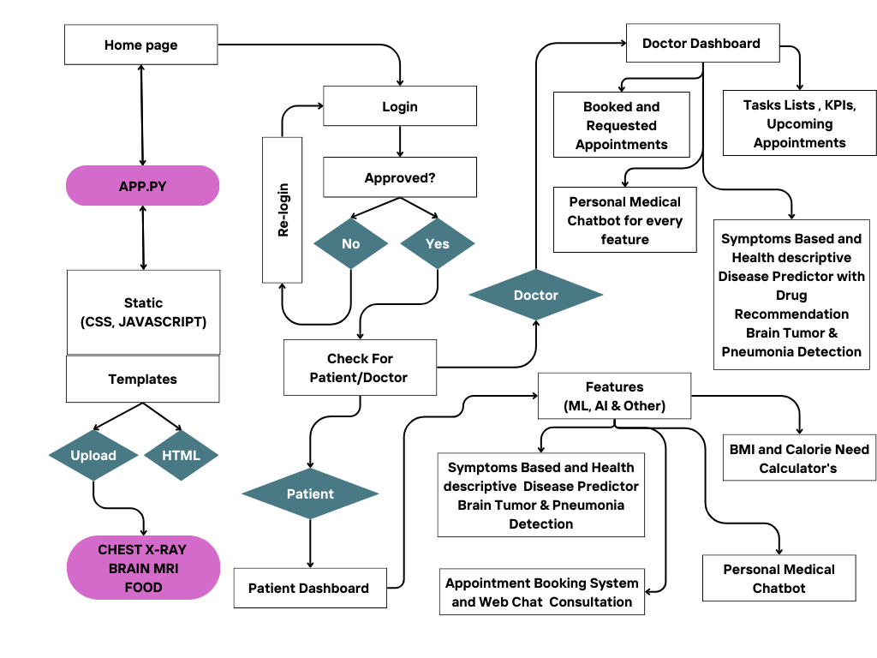

Fig 4.1.1. System Architecture.

The system caters to both patients and doctors, facilitating their interaction through a login process and personalized dashboards. Patients can log in using their credentials and access a dashboard offering functionalities like appointment scheduling. This user-friendly interface allows them to browse available time slots and conveniently book appointments with healthcare providers [Appointment Booking System and Web Chat Consultation]. Additionally, an AI-powered chatbot assists patients by answering frequently asked medical questions [Personal Medical Chatbot]. The system might also allow patients to upload or download templates, possibly related to medical forms or questionnaires [Templates].

Doctors can log in similarly and access their dashboard. This dashboard equips them with functionalities to manage their schedules, view upcoming appointments, and potentially accept or decline new patient requests [Booked and Requested Appointments]. The system might also provide a dedicated section for doctors to view their tasks, key performance indicators (KPIs), and upcoming appointments, offering a consolidated view of their workload [Tasks Lists, KPIs, Upcoming Appointments].

Beyond these core functionalities, the system leverages AI for advanced features. One such feature analyzes a patient's symptoms and suggests potential disease diagnoses along with possible medication recommendations, although it's crucial to emphasize that these are solely predictions and shouldn't replace professional medical advice [Symptoms Based and Health descriptive Disease Predictor with Drug Recommendation]. The flowchart also hints at the potential for AI-powered medical image analysis, such as brain tumor and pneumonia detection, although the specifics remain unclear [Brain Tumor & Pneumonia Detection].

The system is likely built with front-end technologies like CSS and JavaScript, and the flowchart suggests the presence of additional unspecified ML, AI, and other features. Overall, this architecture represents a promising patient care system that streamlines appointments, facilitates virtual consultations (potentially through a web chat feature), leverages AI-powered tools, offers patient-centric resources, and provides functionalities to support doctors' workflow. It's important to remember that this is a high-level overview, and the actual system might encompass greater complexities.

**4.2. Subsystems Architecture**

**4.2.1. Health Condition Description based Disease Predictor**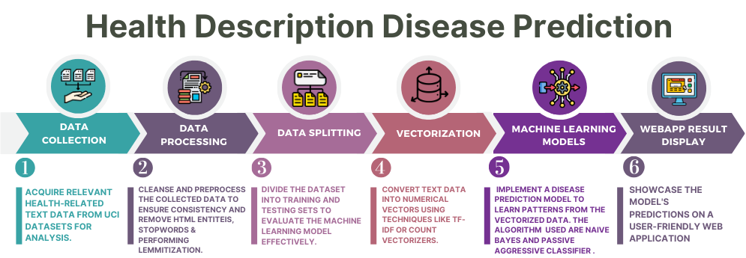

Fig 4.2.1. Health Condition Description based Disease Predictor Architecture.

The Disease Predictor, which relies on advanced techniques to analyze text data for predicting diseases based on health condition descriptions, employs a combination of Count Vectorizer and TF-IDF. These methods transform the free-form descriptions into numerical representations, making them interpretable for machine learning models.Count Vectorizer tallies word frequencies, while TF-IDF considers the importance of each word, capturing the nuances of natural language in a mathematical form. This transformation extracts the core essence of health condition descriptions.Two machine learning algorithms, Naive Bayes and Passive Aggressive Classifier, are then utilized to learn from these numerical representations and identify meaningful diagnostic patterns. Naive Bayes assumes independence among features, providing a simple yet powerful approach, while Passive Aggressive Classifier actively updates itself to improve predictions.

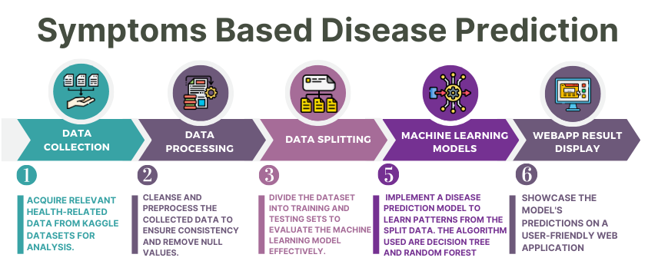**4.2.2. Symptoms based Disease Predictor**

Fig 4.2.2. Symptoms based Disease Predictor Architecture

The Symptoms-based Disease Predictor is an invaluable part of HealthAI Connect, designed to predict diseases based on a set of symptoms provided by the user. This feature stands out for its remarkable ability to detect up to 41 different diseases using a total of 132 symptoms. It achieves this using two popular machine learning algorithms: Decision Tree and Random Forest. These algorithms have shown exceptional accuracy and efficacy in predicting diseases. Think of Decision Trees and Random Forest as expert detectives unravelling a medical mystery. Decision Trees methodically ask questions about symptoms, using each answer to narrow down potential diseases. Conversely, Random Forest functions as a collaborative team of detectives. Each 'detective' (or tree) autonomously investigates symptoms and collectively votes on potential diseases. This cohesive approach enhances diagnostic accuracy by leveraging diverse perspectives.

**4.2.3. RAG Medical Chatbot**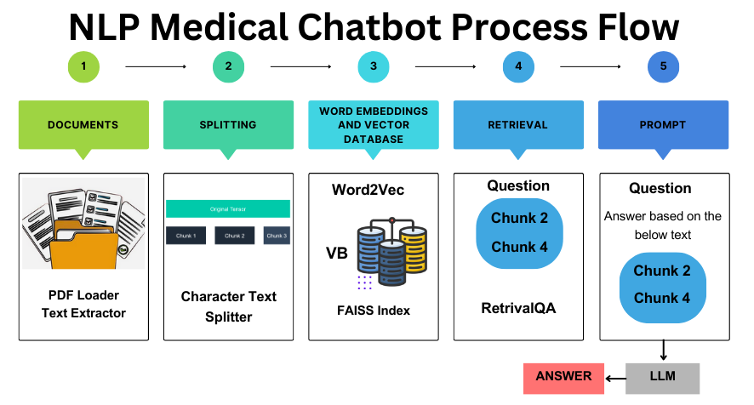

Fig 4.2.3. RAG Medical Chatbot Architecture

The RAG Medical Chatbot is an innovative feature of HealthAI Connect, designed to offer users precise and concise answers to their medical queries. This chatbot utilizes the power of NLP techniques, using word embeddings, vector databases, and advanced frameworks to deliver prompt and intelligible answers. By integrating cutting-edge technologies such as Langchain framework and LLMs, this chatbot makes sure that users receive relevant and summarized information.

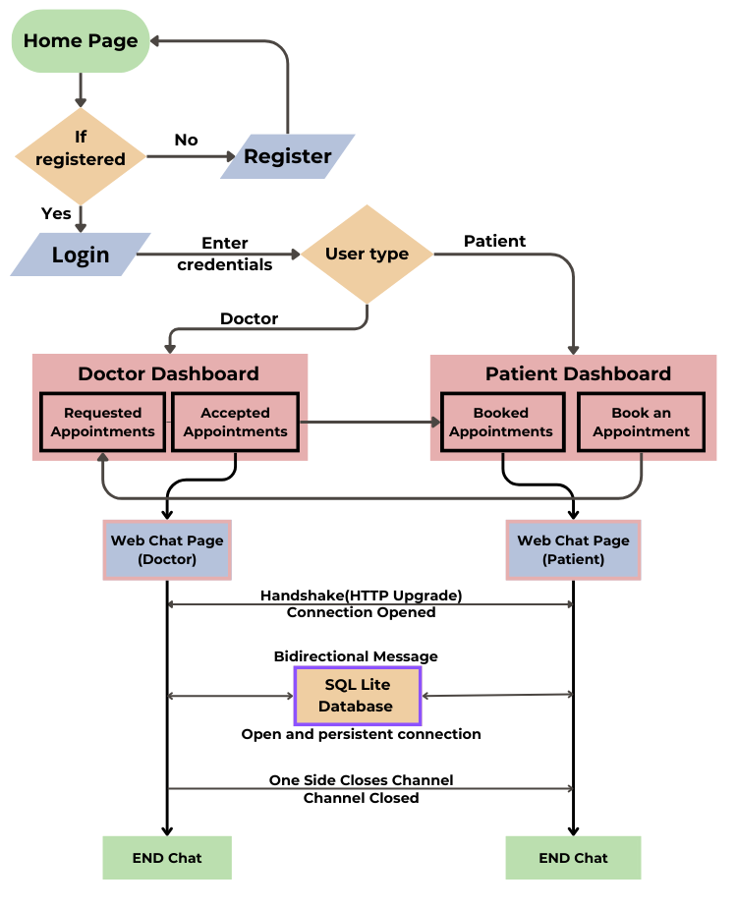**4.2.4. Appointment booking system and Web Chat Consultation**

Fig 4.2.4. Appointment booking system and Web Chat Consultation Architecture

The Appointment Booking System and Web Chat Consultation feature of HealthAI Connect revolutionizes the way patients and doctors interact, making scheduling appointments and conducting consultations seamless and efficient. The core components include patient and doctor dashboards, appointment booking forms, appointment tables, and a web chat interface all of which facilitate easy appointment booking and management, and enhance doctor-patient interaction. The patient dashboard enables users to schedule appointments conveniently through a simple form, while the doctor dashboard provides a platform for managing appointment requests and viewing upcoming sessions. By using technologies such as WebSockets and SQL Lite database, the web chat interface facilitates real-time communication between patients and doctors, aiming to enhance communication and accessibility for both patients and doctors.

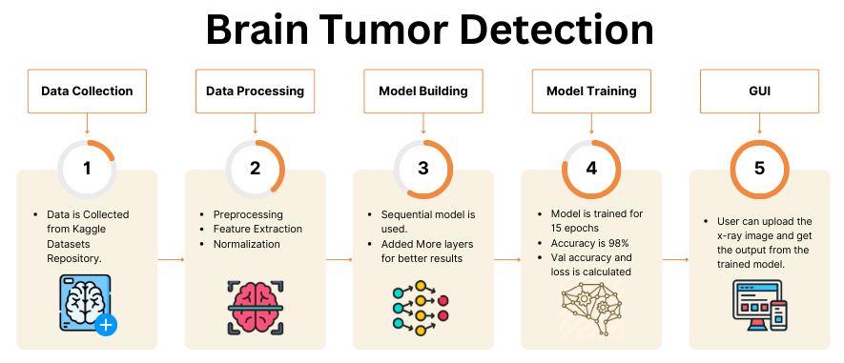**4.2.5. Brain Tumour Detection**

Fig 4.2.5. Brain Tumour Detector Architecture

The Brain Tumor Detection is an important feature within HealthAI Connect, empowering users to submit brain X-ray images to identify concerning abnormalities. By applying the knowledge of pre-existing CNN models through transfer learning techniques, we were able to develop a robust model specialized for brain tumor detection. The transfer learning approach enabled us to expand the pre-trained model’s capabilities to the specialized domain of medical images. By inheriting already learned feature representations, the model gained a running start on tumor detection rather than learning from scratch. The culmination of transfer learning and meticulous fine-tuning was a CNN expertly primed for the critical task at hand - the accurate identification of malignant tumors to improve outcomes through early diagnosis and treatment. The customization process entails incorporating additional layers, fine-tuning parameters, and training the model on a dataset comprising labelled brain X-ray images denoting tumor and non-tumor classes.

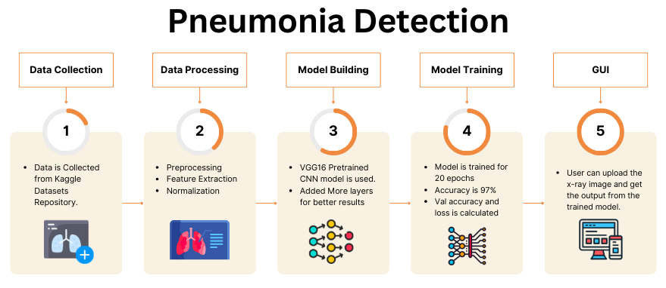**4.2.6. Pneumonia Detection**

Fig 4.2.6. Pneumonia Detector Architecture

Pneumonia Detection is a crucial feature within HealthAI Connect, enabling users to upload chest X-ray images for the prediction of pneumonia. The model architecture used for pneumonia detection is based on the VGG16 (Visual Geometry Group 16) convolutional neural network. VGG16 is a deep learning architecture that has been pre-trained on the ImageNet dataset, which contains millions of images across thousands of categories. By leveraging the pre-trained weights from VGG16, the model can effectively learn features from chest X-ray images and make accurate predictions regarding the presence of pneumonia.

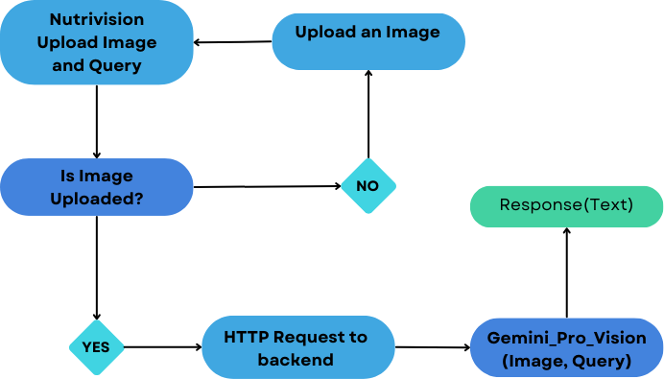**4.2.7. NutriVision**

Fig 4.2.7. NutriVision Architecture

This flowchart illustrates the NutriVision system's food analysis process. Users upload a food image and optionally include a related query. The system transmits both the image and query (if provided) to the Gemini Pro Vision API. Leveraging advanced algorithms, the API scrutinizes the image's visual features and integrates contextual information from the query. Following analysis, the API furnishes a detailed response to the user, encompassing nutritional content and dietary insights. NutriVision thus bridges cutting-edge image analysis with user queries, empowering informed dietary decisions through seamless integration with the Gemini Pro Vision API.

**4.3. Process Flow and Input/Output Formats**

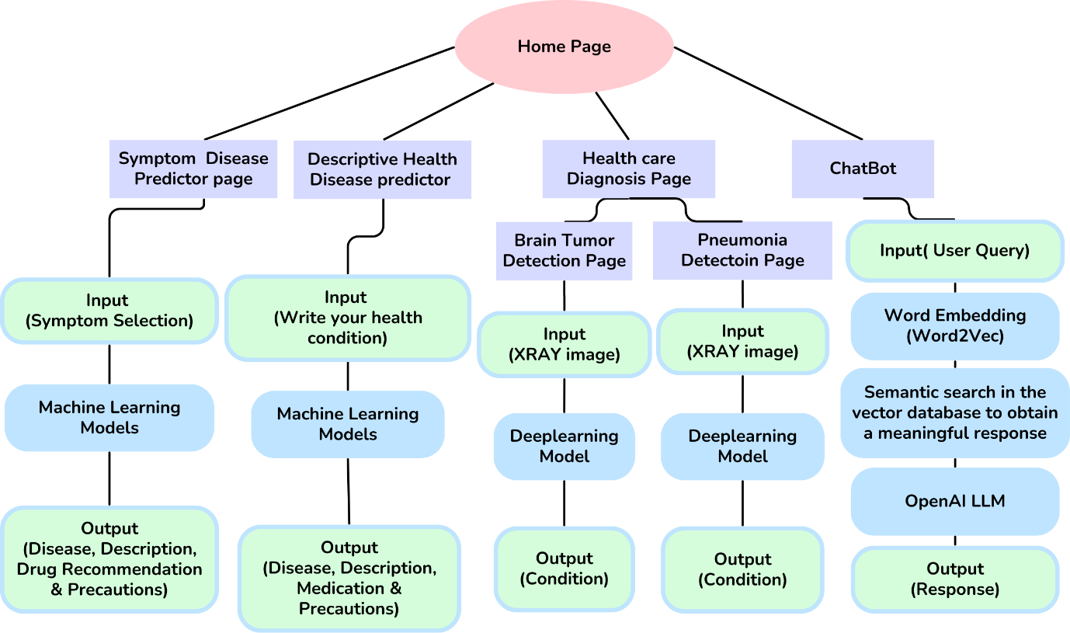

Fig 4.3. Process Flow and Input/Output Formats

The flowchart describes a medical system that integrates various functionalities. It starts with a login/register section where users can create unique credentials to enter the system. Upon logging in, users are directed to a dashboard UI. Here, they can navigate through different sections depending on their needs. One section allows users to interact with a chatbot, which utilizes AI models to answer their queries. Then there’s another section Healthcare Diagnosis which can be used for medical image diagnosis. For instance, a user can upload an X-ray image and the system will use deep learning models to analyze it. There are sections for disease prediction it will provide outputs such as the possible disease, description, medication (only for doctors) and precautions.

**5.IMPLEMENTATION**

Implementing the defined system involves a structured approach to ensure successful deployment and functionality. Let’s begin with features one by one.

**5.1. Implementation of Health description disease predictor**

In the implementation of the Disease Predictor, cutting-edge methodologies converge to revolutionize disease prediction based on health condition descriptions. This delves into the intricate fusion of techniques and algorithms powering the predictive capabilities of the system. The Disease Predictor harnesses advanced techniques to analyze text data for disease prediction, employing Count Vectorizer and TF-IDF to transform free-form descriptions into numerical representations. Count Vectorizer tallies word frequencies, while TF-IDF considers word importance, capturing natural language nuances mathematically. Subsequently, Naive Bayes and Passive Aggressive Classifier algorithms learn from these representations to identify diagnostic patterns. Naive Bayes assumes feature independence, offering simplicity and power, while Passive Aggressive Classifier dynamically updates for improved predictions.

**5.1.1. Data Collection**

This project's data collection strategy focused on the dataset retrieved from the UCI Machine Learning Repository (UCI ML Repository) hosted by the University of California, Irvine. This renowned repository serves as a valuable resource for researchers, offering a diverse collection of open-source datasets, including a significant portion dedicated to healthcare and medicine.

The chosen dataset, offers a rich source of information on patients' experiences with various medications. These reviews likely encompass details such as medication names, patient demographics, ratings, and potentially textual descriptions of side effects or therapeutic effects. By leveraging this data, the project aimed to train a "health descriptive disease predictor" – a machine learning model capable of analyzing patient information and suggesting potential disease predictions based on reported experiences of the patient and their condition. It's crucial to reiterate that such predictions are not definitive diagnoses and should never replace professional medical advice.

**5.1.2. Preprocessing**

Due to limitations in computational power, our model is tailored to predict only eight diseases: 'Birth Control', 'Depression', 'Pain', 'Anxiety', 'Bipolar Disorder', 'ADHD', 'Diabetes, Type 2', and 'High Blood Pressure'. To conduct comprehensive analysis, we commenced with Exploratory Data Analysis (EDA), initially eliminating stopwords. Stopwords, such as "the", "is", "in", etc., are ubiquitous in language but often lack substantive meaning in NLP tasks. Following this, we executed lemmatization on the textual data. Lemmatization involves reducing words to their base or dictionary form, stripping away inflectional endings. This process ensures uniformity in word representation, facilitating more accurate analysis.

Post-lemmatization, we crafted word clouds for each disease. These visualizations highlight the most frequently occurring words in disease descriptions, offering valuable insights into the predominant themes and language used to describe each condition. Such analysis aids in identifying key terms associated with each disease, thereby enhancing our understanding and interpretation of the data.

For example, the word cloud for the depression is given below.

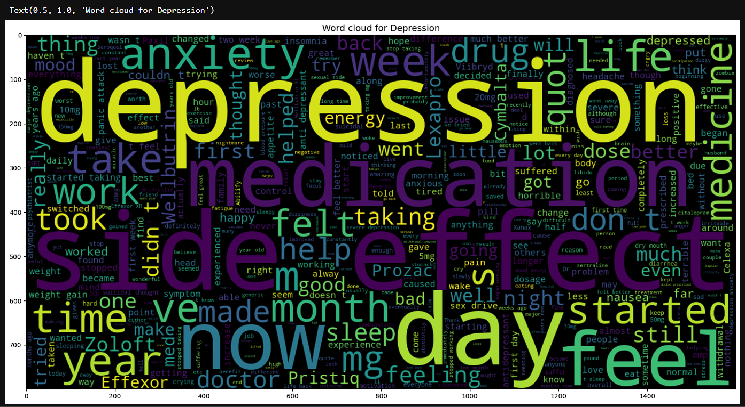

Fig 5.1.2. Word Cloud for Depression

Following preprocessing, the text undergoes vectorization, a pivotal step wherein sentences are transformed into numerical representations, forming vectors. These numerical representations enable machine learning algorithms to process and analyze textual data effectively. Subsequently, the dataset is partitioned into training (80%) and testing (20%) subsets. This division ensures that the model is trained on a substantial portion of the data while retaining a separate subset for evaluation, thereby assessing its performance on unseen data.

**5.1.3. Machine Learning**

Machine learning is the ability that gives the computer to learn without being explicitly programmed. There are two types of machine learning:

Supervised Learning: supervised learning is the learning of the labelled data. It is the types of machine learning that maps the input and output based on the examples input-output pairs. In supervised learning each training data having pairs of input and desired outputs values. Supervised learning algorithm analyses the training data and produces a function which can be used for mapping of new data. Supervised Learning The output to solve the supervised learning algorithm are as:

● Determine the types of data, before doing anything else the user should understand which types of data set is to be used for training the data.

● Gathered the training data sets either in form of human experts or from measurements.

● Determine the feature of inputs from the learned data and depends on the inputs it changed into feature vector; number of features should not be large but should contains enough information to accurately predict the outputs.

● Check the learned function and the learned algorithm for example we use support vector machines or decisions tree.

● Complete the design and run the trained data sets.

Unsupervised Learning:

Unsupervised learning is a type of machine learning that helps in finding the previously unknown patterns in the data set without any known labels. It is known as self- organization and allows modelling probability densities of given inputs.

Semi Supervised algorithm: It’s like the middle man which have some labelled data and some unlabelled which can be prosed by the both the structured and unsupervised learning

Reinforcement Learning: This type of learning is used to reinforce or strengthen the network based on critic information. That is, a network being trained under reinforcement learning, receives some feedback from the environment.

**Naive Bayes**

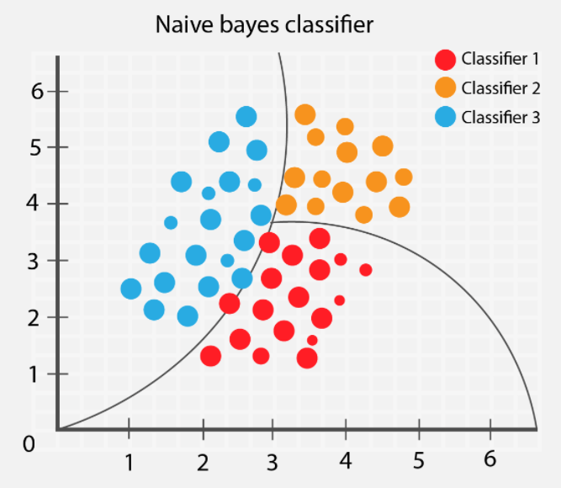In machine learning, Naïve Bayes classification is a straightforward and powerful algorithm for the classification task. Naïve Bayes classification is based on applying Bayes’ theorem with strong independence assumption between the features. Naïve Bayes classification produces good results when we use it for textual data analysis such as Natural Language Processing.

fig 5.1.3 (a) A Graphical Illustration of a Naive Bayes Classifier

Naïve Bayes models are also known as simple Bayes or independent Bayes. All these names refer to the application of Bayes’ theorem in the classifier’s decision rule. Naïve Bayes classifier applies the Bayes’ theorem in practice. This classifier brings the power of Bayes’ theorem to machine learning. Naïve Bayes Classifier uses the Bayes’ theorem to predict membership probabilities for each class such as the probability that given record or data point belongs to a particular class. The class with the highest probability is considered as the most likely class. This is also known as the Maximum A Posteriori (MAP).

The MAP for a hypothesis with 2 events A and B is

MAP (A)

= max (P (A | B))

= max (P (B | A) * P (A))/P (B)

= max (P (B | A) * P (A))

Here, P (B) is evidence probability. It is used to normalize the result. It remains the same, So, removing it would not affect the result. Naïve Bayes Classifier assumes that all the features are unrelated to each other. Presence or absence of a feature does not influence the presence or absence of any other feature.

$$P\left(H | E\right)=\frac{P\left(E | H\right)×P\left(H\right)}{P\left(E\right)}$$

fig 5.1.3 (b) Bayes Theorem

where, P(H∣E): The probability of hypothesis HHH given the evidence EEE.

P(E∣H): The probability of evidence EEE given that hypothesis HHH is true.

P(H): The initial probability of hypothesis HHH before observing evidence EEE.

P(E): The total probability of observing evidence EEE under all possible hypotheses.

In real world datasets, we test a hypothesis given multiple evidence on features. So, the calculations become quite complicated. To simplify the work, the feature independence approach is used to uncouple multiple evidence and treat each as an independent one. Naïve Bayes is one of the most straightforward and fast classification algorithm. It is very well suited for large volume of data. It is successfully used in various applications such as : Spam filtering, Text classification, Sentiment analysis, Recommender systems. It uses Bayes theorem of probability for prediction of unknown class.

**Passive Aggressive Classifier**

The passive aggressive classifier is a machine learning algorithm that is used for classification tasks. This algorithm is a modification of the standard Perceptron algorithm. The passive aggressive classifier was first proposed in 2006 by Crammer et al. as a way to improve the performance of the Perceptron algorithm on linearly separable data sets.

The passive aggressive classifier algorithm falls under the category of online learning algorithms, can handle large datasets, and updates its model based on each new instance it encounters. The passive aggressive algorithm is an online learning algorithm, which means that it can update its weights as new data comes in. The passive aggressive classifier has a parameter, namely, the regularization parameter, C that allows for a tradeoff between the size of the margin and the number of misclassifications. In each iteration, the passive aggressive classifier looks at a new instance, assesses whether it has been correctly classified or not, and then updates its weights accordingly. If the instance is correctly classified, there is no change in weight. However, if it is misclassified, the passive aggressive algorithm adjusts its weights in order to better classify future instances based on this misclassified instance. The degree to which the Passive Aggressive algorithm adjusts its weights is dependent on the regularization parameter C and how confident it is in the classification of that particular instance.

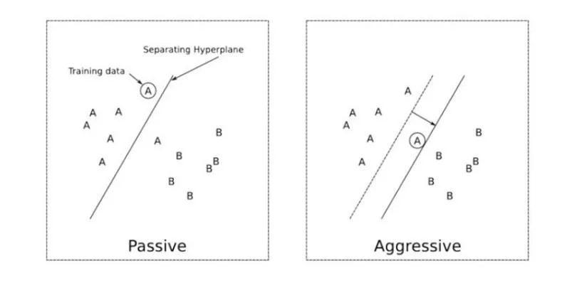The passive aggressive classifier works by taking a set of training data and dividing it into two groups: a training set and a test set. The passive aggressive classifier then uses the training set to learn how to correctly classify objects into one of two categories. Once it has learned how to do this, it is then tested on the data in the test set, and its accuracy is measured.

fig 5.1.3 (c) Illustration of Passive & Aggressive

The passive aggressive classifier can be trained using a variety of different loss functions, such as the hinge loss (PA-I) or the squared hinge loss (PA-II). The hinge loss is a linear loss function that is used to minimize the distance between two decision boundaries. This makes it a good choice for situations where you want to classify objects into two categories as accurately as possible. For example, if you are using the passive aggressive classifier to identify cancer cells, you would want to use the hinge loss function so that the boundaries between cancer cells and healthy cells are as distinct as possible. The squared hinge loss is a nonlinear loss function that is used to minimize the distance between two decision boundaries. The squared hinge loss is a variant of the hinge loss that is typically used when the data has a Gaussian distribution. The squared hinge loss is similar to the hinge loss, but it takes into account the variance of the data. This can be helpful when trying to minimize the error in prediction.

**TF-IDF classifier:**

The TF-IDF (Term Frequency-Inverse Document Frequency) classifier is renowned for its effectiveness in document classification tasks within text mining and natural language processing. It hinges on a nuanced evaluation of term importance, achieved through meticulous calculations of term frequency (TF) and inverse document frequency (IDF). TF quantifies how often a term appears within a document, while IDF measures the rarity of a term across a document corpus. By combining TF and IDF, TF-IDF assigns weights to terms based on their significance within individual documents and across the entire corpus.

In the TF-IDF computation process, term frequency is initially calculated for each term in a document, followed by determining the inverse document frequency. These values are then multiplied to yield the TF-IDF score, capturing the term's importance in the document relative to the entire corpus. During training, the TF-IDF classifier extracts features and trains a classification algorithm, such as logistic regression or support vector machines, to learn the relationship between feature vectors and class labels.

In the prediction phase, the TF-IDF classifier transforms new text data into TF-IDF vectors for classification. This process mirrors training but focuses on novel instances. Despite its effectiveness, the TF-IDF classifier has limitations. It may be influenced by noise and irrelevant terms in the text data, and its bag-of-words model may overlook semantic relationships between terms. Additionally, accurate IDF estimation requires a diverse and extensive corpus, which may pose challenges in certain scenarios.

**5.1.4. Training Phase:**

The training phase commences by applying the Naïve Bayes and Passive Aggressive Classifier algorithms, both utilizing the TF-IDF (Term Frequency-Inverse Document Frequency) technique. TF-IDF is employed to minimize the complexity of training by emphasizing the significance of terms in the document while mitigating the influence of common terms that occur across multiple documents. This approach enhances the model's ability to discern relevant patterns and associations within the data, ultimately contributing to improved predictive performance. In testing, Naive Bayes achieved accuracies of 89% with Count Vectorizer and 77.9% with TF-IDF. However, Passive Aggressive Classifier outperformed it with accuracies of 90% using Count Vectorizer and 93.9% using TF-IDF. Hence, the combination of Passive Aggressive Classifier and TF-IDF emerges as the most effective technique for extracting insights from health condition descriptions and delivering accurate diagnostic predictions. The confusion matrix for accuracy of 93.9% using Passive aggressive Classifier is shown below

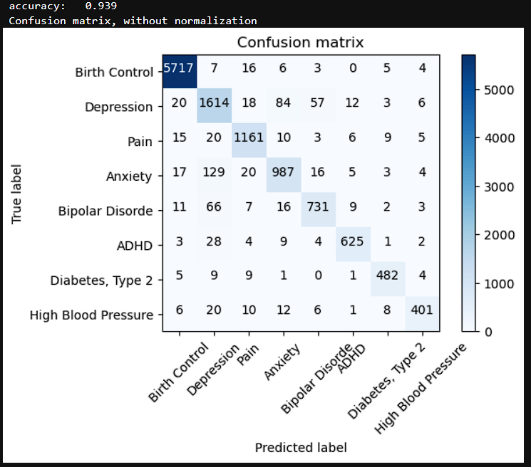Fig 5.1.4. Confusion Matrix of PAC

In summary, the Disease Predictor's integration of sophisticated natural language processing and machine learning enables the understanding of subjective health condition descriptions and the identification of likely diseases. The transformer-based approach converts unstructured data into informative numerical representations, facilitating the discernment of patterns and relationships.

**5.2. Implementation of Symptom based disease predictor**

The Symptoms-based Disease Predictor is an invaluable part of HealthAI Connect, designed to predict diseases based on a set of symptoms provided by the user. This feature stands out for its remarkable ability to detect up to 41 different diseases using a total of 132 symptoms. It achieves this using two popular machine learning algorithms: Decision Tree and Random Forest. These algorithms have shown exceptional accuracy and efficacy in predicting diseases.

**5.2.1. Data Collection**

Kaggle boasts a vast collection of datasets encompassing diverse domains. For your project, the "Disease Prediction" dataset by KAUSHIL268 serves as a valuable resource for data collection. The dataset most likely contains numerous features, potentially exceeding 100. These features likely represent various symptoms or health indicators that a patient might experience. Each feature could correspond to a specific symptom, like cough, fever, or fatigue. The dataset also includes a target variable, possibly labeled as "prognosis" or a similar term. This variable corresponds to the actual disease or medical condition associated with the set of symptoms represented by the features. Kaggle provides free access to the dataset, eliminating financial barriers and promoting open-source research practices. This fosters collaboration and knowledge sharing within the research community. The chosen dataset directly addresses your project's needs by offering symptom-disease associations, crucial for building a disease prediction model. The quality of the data on Kaggle is often vetted by the community, increasing its reliability for research purposes. Utilizing an established dataset from Kaggle allows for potential standardization and future benchmarking of your model's performance against others who might have used the same dataset. This enables researchers to compare the effectiveness of different disease prediction models.

**5.2.2. Preprocessing**

Data cleaning is a critical step in the preprocessing phase aimed at identifying and rectifying issues within the dataset to ensure its integrity and reliability for analysis. Missing values can arise due to various reasons such as data entry errors, equipment failures, or intentional omissions. Depending on the nature of the missing data and the analysis requirements, missing values can be handled through techniques such as imputation (replacing missing values with estimated values based on other data points) or deletion (removing rows or columns with missing values). The image provides an overview of the dataset, detailing the unique diseases and their corresponding number of occurrences, as well 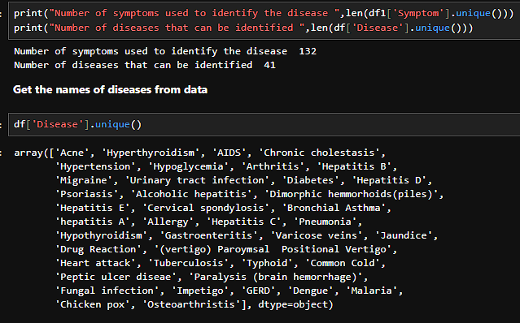as the total number of symptoms present in the dataset.

fig 5.2.2. Dataset information

**5.2.3. Decision Trees**

A decision tree is one of the most powerful tools of supervised learning algorithms used for both classification and regression tasks. It builds a flowchart-like tree structure where each internal node denotes a test on an attribute, each branch represents an outcome of the test, and each leaf node (terminal node) holds a class label. It is constructed by recursively splitting the training data into subsets based on the values of the attributes until a stopping criterion is met, such as the maximum depth of the tree or the minimum number of samples required to split a node. During training, the Decision Tree algorithm selects the best attribute to split the data based on a metric such as entropy or Gini impurity, which measures the level of impurity or randomness in the subsets. The goal is to find the attribute that maximizes the information gain or the reduction in impurity after the split.

Some of the common Terminologies used in Decision Trees are as follows:

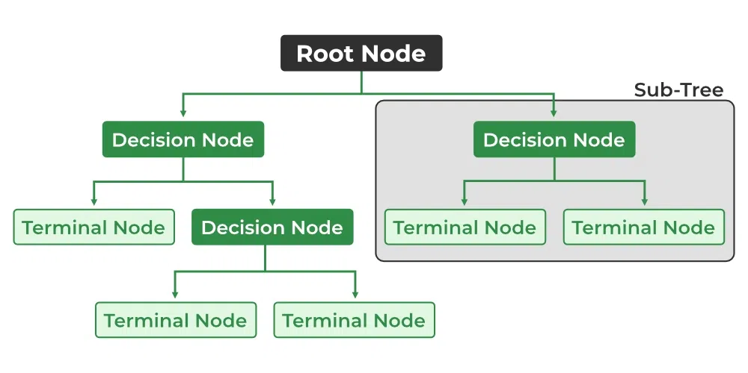In Decision Trees, several key terminologies play crucial roles in understanding the structure and function of the model. At the topmost level sits the Root Node, representing the entire dataset and serving as the starting point for the decision-making process. Decision or Internal Nodes, meanwhile, symbolize choices based on input features, branching out to Leaf or Terminal Nodes that signify class labels or numerical values. Splitting occurs when a node divides into sub-nodes using a split criterion and a selected feature, leading to the creation of Branches or Sub-Trees.

fig 5.2.3. Key Components of Decision Tree

Parent Nodes give rise to one or more Child Nodes through splitting, with each Child Node representing a subset of the data. Impurity measures the target variable's homogeneity within a subset, quantifying the degree of randomness or uncertainty. Common impurity metrics include the Gini index and entropy for classification tasks. In regression tasks, Variance assesses the variability between predicted and target variables across different samples. Information Gain gauges the reduction in impurity achieved by splitting a dataset on a particular feature, guiding the selection of the most informative feature at each node to create purer subsets. Finally, Pruning involves removing branches from the tree that contribute little to information gain or risk overfitting, streamlining the model for improved performance and interpretability.

**5.2.4. Random Forest**

The Random Forest algorithm stands out in the realm of Machine Learning as a potent tree-based technique. Unlike traditional decision trees, Random Forest creates a multitude of Decision Trees during training, each operating on a random subset of the dataset and features. This randomness injects diversity into the ensemble, mitigating overfitting and enhancing prediction accuracy. During prediction, the algorithm aggregates the outcomes of all trees, either by voting (for classification) or averaging (for regression). This collaborative approach yields stable and precise results, making Random Forests a popular choice for classification and regression tasks. They excel at handling complex data, reducing overfitting, and delivering reliable forecasts across various domains.

The algorithm's workflow involves several key steps:

* Ensemble of Decision Trees: Random Forest harnesses ensemble learning, constructing a multitude of Decision Trees. Each tree acts as an independent expert, specializing in different aspects of the data.
* Random Feature Selection: To foster diversity among trees, Random Forest randomly selects subsets of features during training. This ensures that each tree focuses on distinct aspects of the data, enriching the ensemble's predictive capabilities.
* Bootstrap Aggregating (Bagging): A cornerstone of Random Forest's training strategy is bagging, which involves creating multiple bootstrap samples from the original dataset. This introduces variability by sampling instances with replacement, contributing to the model's robustness.
* 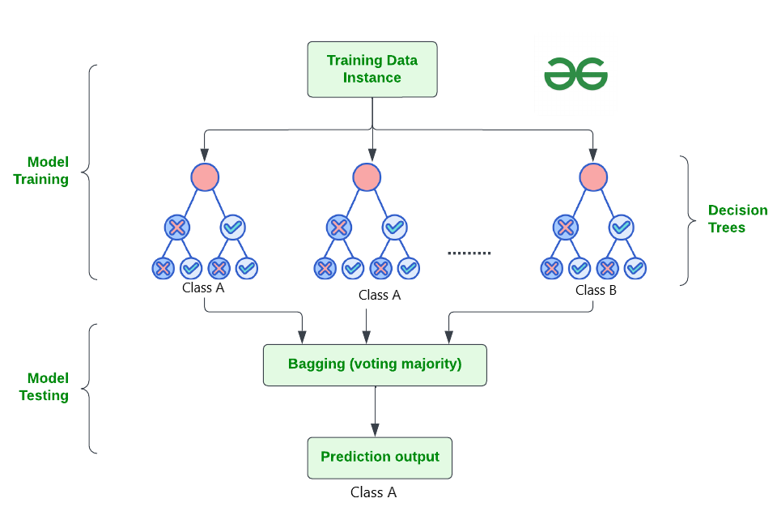Decision Making and Voting: During prediction, each decision tree in the Random Forest casts its vote (classification) or provides a prediction (regression). The final outcome is determined by aggregating these individual predictions through voting or averaging, fostering a balanced and collective decision-making process.

fig 5.2.3. Machine Learning Process of Random Forest

**5.2.5. Training**

When it comes to predicting diseases from symptoms, Decision Trees and Random Forest are like expert detectives trained to analyze data and make informed decisions. They excel in handling complex data like symptom descriptions and can quickly identify patterns that indicate certain diseases. This makes them invaluable tools for the classification task of matching symptoms to diseases accurately.

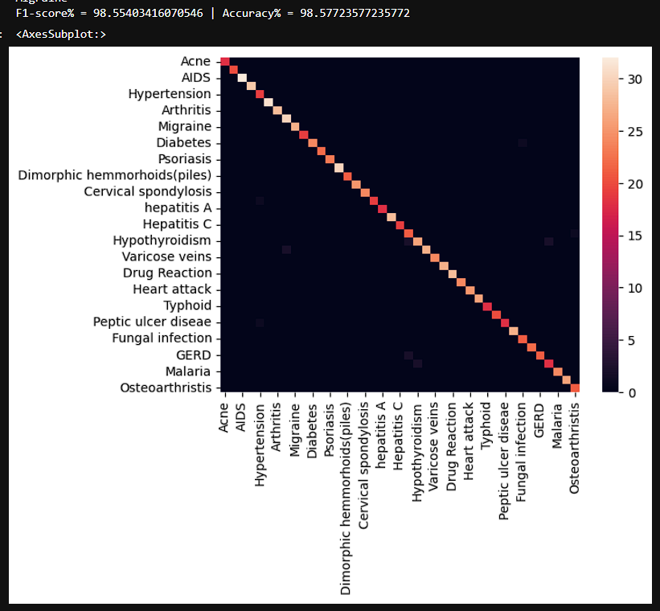The Decision Tree model achieved impressive performance metrics, with an F1-score of 98.46% and an accuracy of 98.48%. During training, the model demonstrated a mean accuracy of 97.76%, with a standard deviation of 0.60%. On the test set, the model maintained high performance, achieving a mean accuracy of 93.49%, with a standard deviation of 4.36%. In comparison, the Random Forest model outperformed the Decision Tree, yielding an F1-score of 98.55% and an accuracy of 98.58%. Utilizing K-fold cross-validation, the Random Forest model exhibited even higher performance consistency. During training, it achieved a mean accuracy of 98.53%, with a minimal standard deviation of 0.34%. On the test set, the model sustained strong performance, with a mean accuracy of 95.53% and a standard deviation of 1.95%.

fig 5.2.5. (a) Performance of Random Forest on Disease Prediction

Overall, both models demonstrated robust performance, with the Random Forest model exhibiting slightly superior accuracy and stability, making it the preferred choice for this classification task.

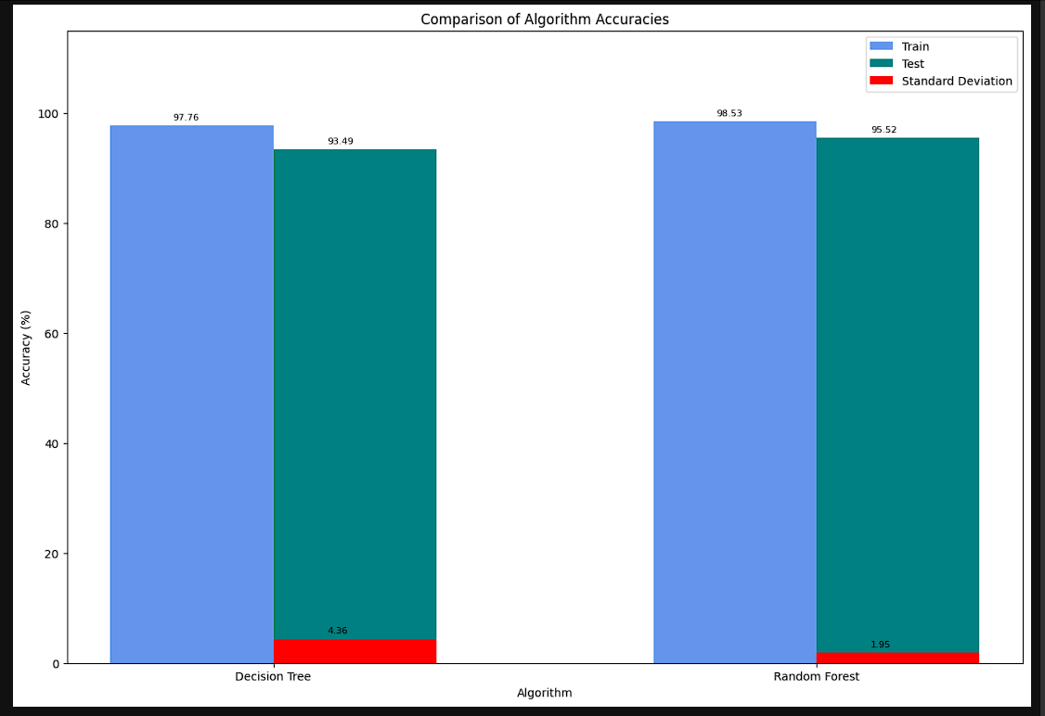

Fig 5.2.5. (b) Comparison of Algorithm Accruacies

In summary, the Symptoms-based Disease Predictor in HealthAI Connect utilizes the powerful algorithms of Decision Trees and Random Forest to accurately identify diseases from symptom data. These algorithms excel in making sense of complex symptom descriptions and are highly reliable in their predictions. The impressive accuracy rates achieved by both Decision Trees and Random Forest underscore their effectiveness in assisting healthcare professionals in diagnosing diseases based on symptom data.

**5.3. Implementation of Pneumonia Detection**

Pneumonia Detection is a crucial feature within HealthAI Connect, enabling users to upload chest X-ray images for the prediction of pneumonia.

**5.3.1. Data Collection**

The dataset is collected from Kaggle. The dataset is organized into 3 folders (train, test, val) and contains subfolders for each image category (Pneumonia/Normal). There are 5,863 X-Ray images (JPEG) and 2 categories (Pneumonia/Normal). Chest X-ray images (anterior-posterior) were selected from retrospective cohorts of pediatric patients of one to five years old from Guangzhou Women and Children’s Medical Center, Guangzhou. All chest X-ray imaging was performed as part of patients’ routine clinical care. For the analysis of chest x-ray images, all chest radiographs were initially screened for quality control by removing all low quality or unreadable scans. The diagnoses for the images were then graded by two expert physicians before being cleared for training the AI system. In order to account for any grading errors, the evaluation set was also checked by a third expert.

**5.3.2. Convolutional Neural Network**

A Convolutional Neural Network (CNN) architecture is a deep learning model designed for processing structured grid-like data, such as images. It consists of multiple layers, including convolutional, pooling, and fully connected layers. CNNs are highly effective for tasks like image classification, object detection, and image segmentation due to their hierarchical feature extraction capabilities.

**VGG-16**

The VGG-16 model is a convolutional neural network (CNN) architecture that was proposed by the Visual Geometry Group (VGG) at the University of Oxford. It is characterized by its depth, consisting of 16 layers, including 13 convolutional layers and 3 fully connected layers. VGG-16 is renowned for its simplicity and effectiveness, as well as its ability to achieve strong performance on various computer vision tasks, including image classification and object recognition.

The model’s architecture features a stack of convolutional layers followed by max-pooling layers, with progressively increasing depth. This design enables the model to learn intricate hierarchical representations of visual features, leading to robust and accurate predictions. Despite its simplicity compared to more recent architectures, VGG-16 remains a popular choice for many deep learning applications due to its versatility and excellent performance.

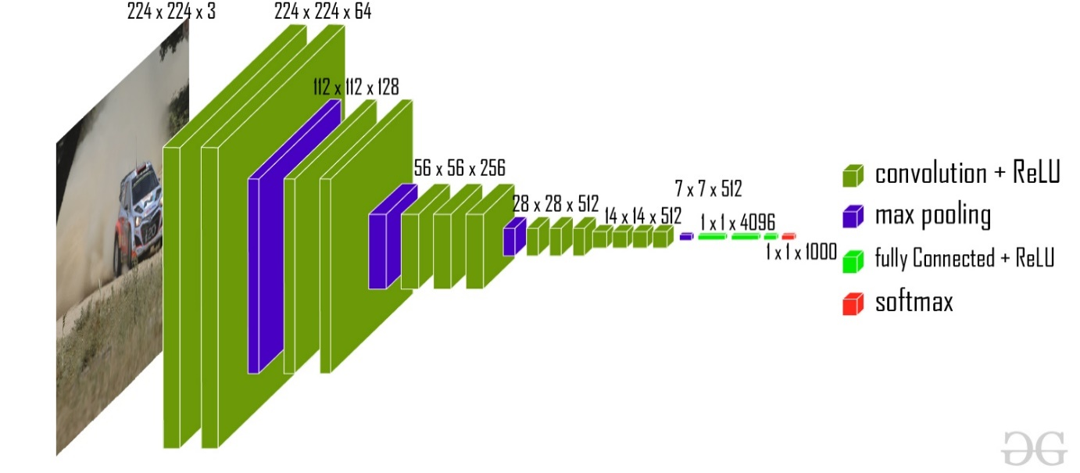

Fig 5.3.2. (a) VGG16 Convolutional Neural Network Architecture

The ImageNet Large Scale Visual Recognition Challenge (ILSVRC) is an annual competition in computer vision where teams tackle tasks including object localization and image classification. VGG16, proposed by Karen Simonyan and Andrew Zisserman in 2014, achieved top ranks in both tasks, detecting objects from 200 classes and classifying images into 1000 categories.

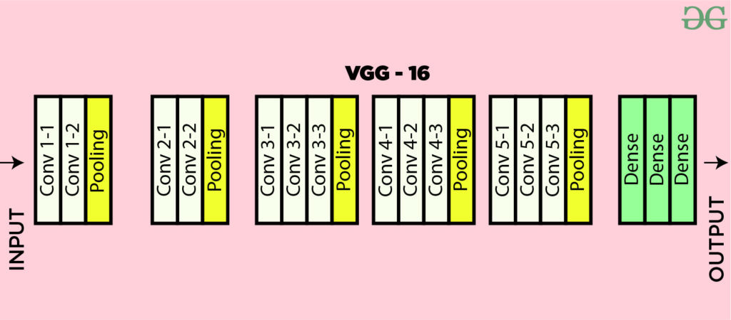

Fig 5.3.2. (b) Layers of the VGG-16 network

**5.3.3. Training**

This feature utilizes a Convolutional Neural Network (CNN) model, which has been pre-trained on a large dataset of images to accurately classify images as affected by pneumonia or normal. The model achieves impressive performance metrics, including a loss of 0.0845 and an accuracy of 97.95% on the training data, and a validation loss of 0.7160 and accuracy of 90.87% on the validation data. The model architecture comprises a total of 14,764,866 parameters, which corresponds to approximately 56.32 megabytes of memory. Among these parameters, 50,178 are trainable, occupying approximately 196.01 kilobytes of memory, while the remaining 14,714,688 parameters are non-trainable, accounting for approximately 56.13 megabytes of memory.

The model architecture used for pneumonia detection is based on the VGG16 (Visual Geometry Group 16) convolutional neural network. VGG16 is a deep learning architecture that has been pre-trained on the ImageNet dataset, which contains millions of images across thousands of categories. By leveraging the pre-trained weights from VGG16, the model can effectively learn features from chest X-ray images and make accurate predictions regarding the presence of pneumonia. Pneumonia is a serious respiratory condition that requires prompt diagnosis and treatment to prevent complications and improve patient outcomes. By utilizing advanced technologies like CNN models, HealthAI Connect enables healthcare professionals to efficiently and accurately identify pneumonia from chest X-ray images. This feature plays a critical role in facilitating early diagnosis, guiding treatment decisions, and optimizing patient care.

In summary, the Pneumonia Detection feature in HealthAI Connect leverages a pre-trained CNN model based on VGG16 architecture to accurately classify chest X-ray images and detect pneumonia with high accuracy. This capability enhances the efficiency and effectiveness of pneumonia diagnosis, underscoring the importance of leveraging advanced technologies in healthcare for improved patient outcomes.

**5.4. Implementation of Brain Tumor Detection**

A Brain tumor is considered as one of the aggressive diseases, among children and adults. Brain tumors account for 85 to 90 percent of all primary Central Nervous System(CNS) tumors. Every year, around 11,700 people are diagnosed with a brain tumor. The 5-year survival rate for people with a cancerous brain or CNS tumor is approximately 34 percent for men and36 percent for women. Brain Tumors are classified as: Benign Tumor, Malignant Tumor, Pituitary Tumor, etc. Proper treatment, planning, and accurate diagnostics should be implemented to improve the life expectancy of the patients. The best technique to detect brain tumors is Magnetic Resonance Imaging (MRI). A huge amount of image data is generated through the scans. These images are examined by the radiologist. A manual examination can be error-prone due to the level of complexities involved in brain tumors and their properties.

**5.4.1. Data Collection**

Dataset is collected from Kaggle. The dataset comprises three folders: "yes," "no," and "pred," collectively containing 3060 Brain MRI Images.

* Yes Folder (Tumorous Images): This folder contains 1500 Brain MRI Images that depict tumorous conditions. These images provide visual representations of brains affected by tumors, serving as crucial data for the analysis and classification of tumorous conditions.
* No Folder (Non-Tumorous Images): The "no" folder houses 1500 Brain MRI Images depicting non-tumorous conditions. These images showcase brains without any signs of tumors, serving as a contrast to the tumorous images and enabling the development of robust classification models.
* Pred Folder (Prediction Images): The "pred" folder encompasses a collection of images intended for prediction purposes. These images may not be labeled as either tumorous or non-tumorous and are utilized to assess the performance of trained models in real-world scenarios, predicting the presence or absence of tumors based on MRI data.

Overall, this dataset provides a comprehensive array of Brain MRI Images, facilitating research and analysis aimed at detecting and classifying tumorous conditions in the brain.

**5.4.2. Preprocessing**

In the data preprocessing phase, we begin by importing necessary libraries and defining the paths to our dataset containing images of brain tumors. We then initialize empty lists to store our data and labels.

The images are loaded using OpenCV, resized to a standardized input size of 64x64 pixels using the PIL library, and appended to the data list. Labels indicating the presence (1) or absence (0) of a tumor are also recorded based on the file names. After processing both tumor and non-tumor images, we convert our lists to NumPy arrays for further processing.

Next, we split our dataset into training and testing sets using the train_test_split function from scikit-learn, with a test size of 20%. Subsequently, we normalize our image data to ensure consistency in feature scaling, and convert our categorical labels into one-hot encoded format using the to_categorical function from Keras.

**5.4.3. Convolutional Neural Network**

A Convolutional Neural Network (CNN) is a type of Deep Learning neural network architecture commonly used in Computer Vision. Computer vision is a field of Artificial Intelligence that enables a computer to understand and interpret the image or visual data.

When it comes to Machine Learning, Artificial Neural Networks perform really well. Neural Networks are used in various datasets like images, audio, and text. Different types of Neural Networks are used for different purposes, for example for predicting the sequence of words we use Recurrent Neural Networks more precisely an LSTM, similarly for image classification we use Convolution Neural networks. In this blog, we are going to build a basic building block for CNN.

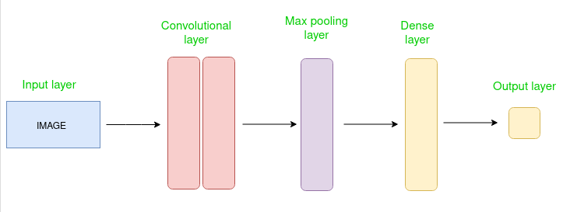Fig 5.4.3. (a) Convolutional Neural Network Process

In a regular Neural Network, there are three types of layers:

1. **Input Layers:** It’s the layer in which we give input to our model. The number of neurons in this layer is equal to the total number of features in our data (number of pixels in the case of an image).
2. **Hidden Layer:** The input from the Input layer is then fed into the hidden layer. There can be many hidden layers depending on our model and data size. Each hidden layer can have different numbers of neurons which are generally greater than the number of features. The output from each layer is computed by matrix multiplication of the output of the previous layer with learnable weights of that layer and then by the addition of learnable biases followed by activation function which makes the network nonlinear.
3. **Output Layer:** The output from the hidden layer is then fed into a logistic function like sigmoid or softmax which converts the output of each class into the probability score of each class.

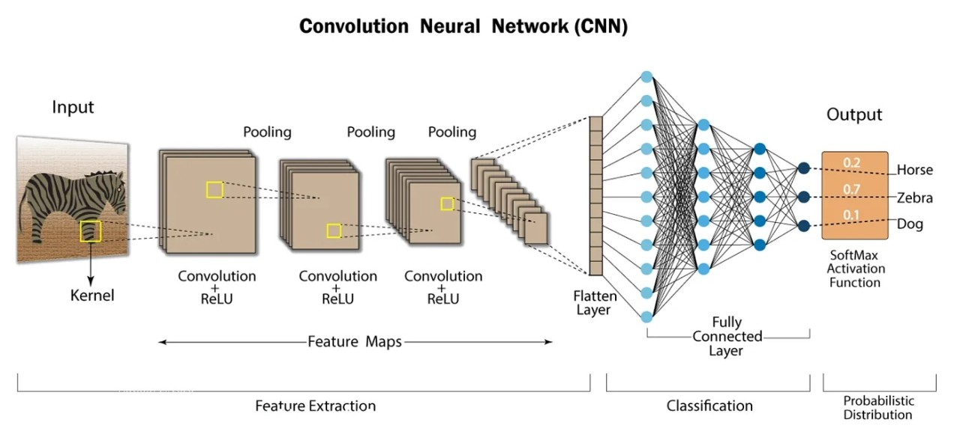Fig 5.4.3. (b) Understanding Convolutional Neural Networks

The data is fed into the model and output from each layer is obtained from the above step is called feedforward, we then calculate the error using an error function, some common error functions are cross-entropy, square loss error, etc. The error function measures how well the network is performing. After that, we backpropagate into the model by calculating the derivatives. This step is called Backpropagation which basically is used to minimize the loss.

**5.4.4. Training**

The model architecture is constructed using the Sequential API from Keras. It consists of three convolutional layers followed by max-pooling layers to extract relevant features from the input images. Each convolutional layer is activated using the ReLU activation function to introduce non-linearity. The model then flattens the output from the convolutional layers and passes it through two fully connected dense layers. A dropout layer is added to mitigate overfitting, followed by a final softmax activation layer to output the predicted probabilities for each class.

For training the model, we compile it using the categorical cross-entropy loss function and the Adam optimizer. We then fit the model to the training data for 15 epochs with a batch size of 16. During training, we monitor both the training and validation accuracy to assess model performance and prevent overfitting. After training, the model is saved for future use.

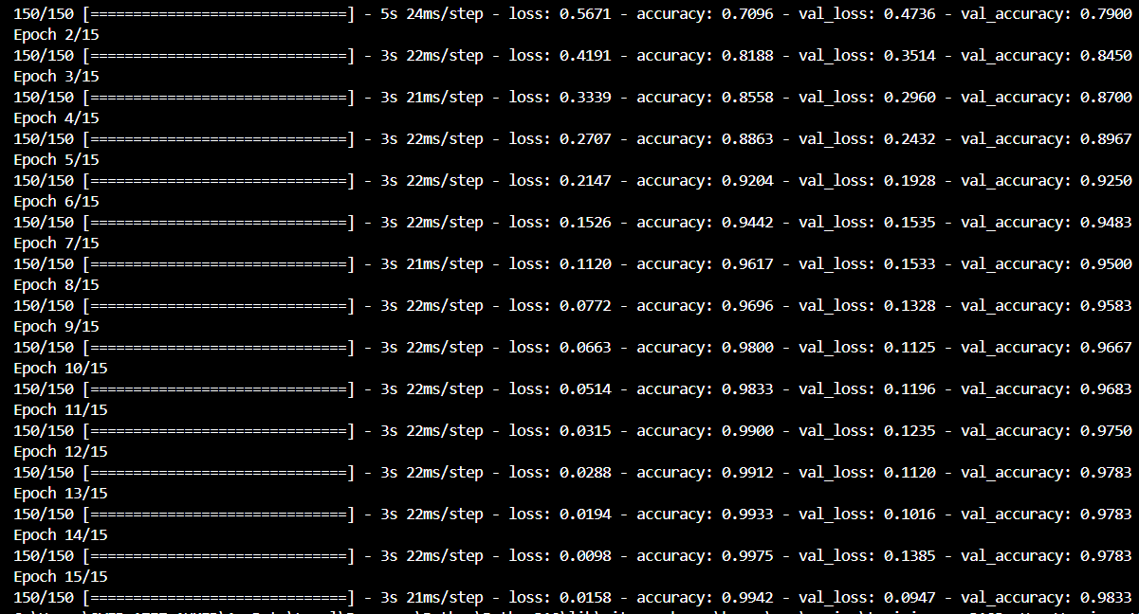Fig 5.4.4. Training Log of a Deep Learning Model

The model for brain tumor detection achieved outstanding performance metrics during training, with a low loss of 0.0158 and high accuracy of 99.42%. On the validation set, the model maintained strong performance, with a slightly higher loss of 0.0947 and an accuracy of 98.33%.

These metrics indicate that the model effectively learned from the training data, accurately classifying brain tumor images with high confidence. Additionally, its performance on unseen validation data suggests that the model generalizes well to new, unseen examples, demonstrating its robustness and reliability in real-world scenarios. Overall, these results underscore the efficacy of the model in detecting brain tumors with high accuracy and reliability.

**5.5. Implementation of RAG (Retrieval Augmented Generation)**

Retrieval-Augmented Generation (RAG) is the process of optimizing the output of a large language model, so it references an authoritative knowledge base outside of its training data sources before generating a response. Large Language Models (LLMs) are trained on vast volumes of data and use billions of parameters to generate original output for tasks like answering questions, translating languages, and completing sentences. RAG extends the already powerful capabilities of LLMs to specific domains or an organization's internal knowledge base, all without the need to retrain the model. It is a cost-effective approach to improving LLM output so it remains relevant, accurate, and useful in various contexts.

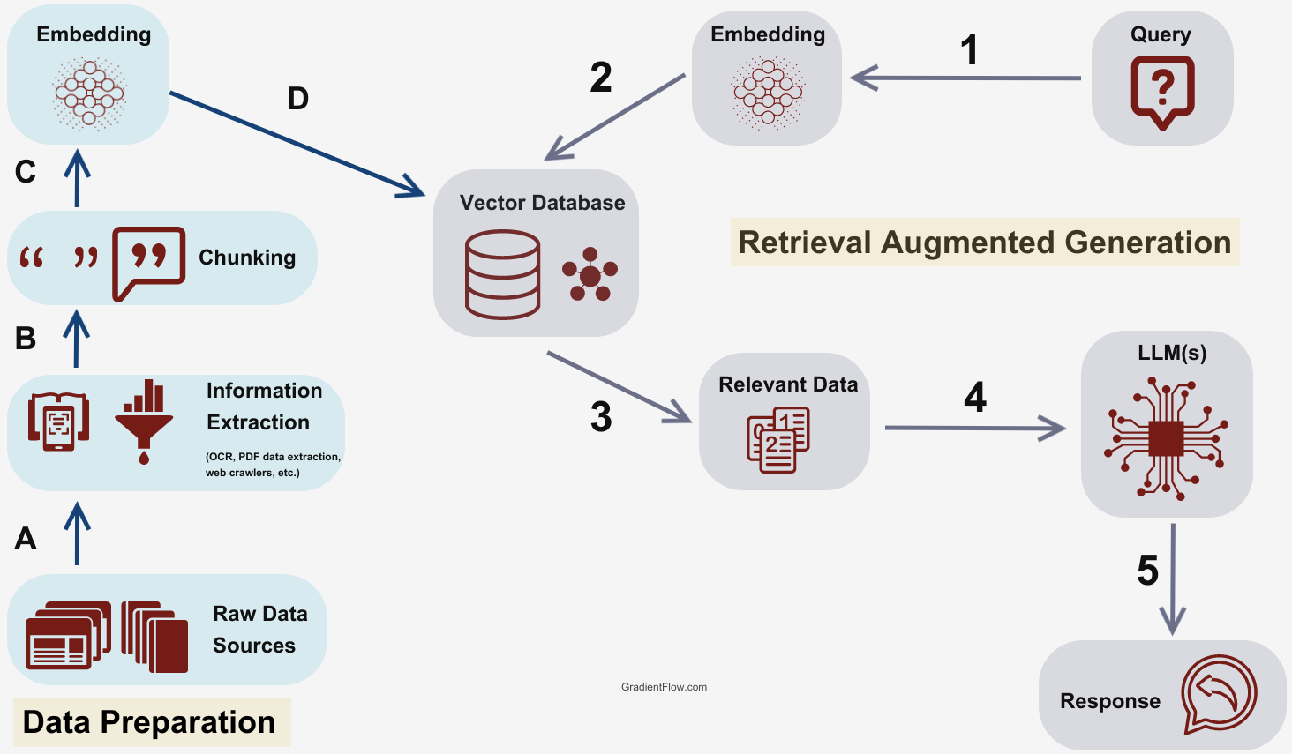 Fig 5.5. Process of Retrieval Augmented Generation (RAG)

To train a robust medical chatbot using Retrieval Augmented Generation (RAG), a significant effort was invested in collecting and preparing medical information. We amassed a comprehensive dataset of medical text data by downloading numerous medical textbooks from InfoBooks, a website offering free medical PDFs in the general medicine category. These textbooks encompassed a broad range of medical topics, providing a substantial foundation of knowledge for the chatbot.

Following data collection, we meticulously preprocessed the information. This critical stage involved eliminating errors and inconsistencies within the text data. Additionally, we ensured consistent formatting across the compiled materials to optimize the data's usability for the RAG system. This preprocessing step guaranteed the information was presented in a way that the RAG system could efficiently understand and utilize.

After preprocessing the data, we proceeded with information extraction. Here, we employed sophisticated techniques to identify and isolate key medical entities from the vast amount of text. These entities could encompass diseases, medications, symptoms, and other crucial medical concepts. By incorporating named entity recognition (NER), we were able to pinpoint these critical elements within the text data. Furthermore, sentence segmentation and part-of-speech tagging were potentially utilized to structure the information in a way that facilitated the RAG system's comprehension.

Finally, the processed and enriched medical knowledge was meticulously integrated into a singular format. This essentially involved creating a comprehensive knowledge base or document store that the RAG system could readily access and leverage whenever responding to user queries. In our case, this culminated in the creation of a singular "super textbook" that the chatbot could use as a reference during user interactions. This super textbook served as the foundation of the chatbot's medical expertise. Through this comprehensive data collection and processing effort, we assembled a robust knowledge base for the RAG-powered medical chatbot. This extensive dataset empowers the chatbot to retrieve relevant medical information and answer user queries with precision. The RAG Medical Chatbot is an innovative feature of HealthAI Connect, designed to offer users precise and concise answers to their medical queries. This chatbot utilizes the power of NLP techniques, using word embeddings, vector databases, and advanced frameworks to deliver prompt and intelligible answers. By integrating cutting-edge technologies such as Langchain framework and OpenAI LLMs, this chatbot makes sure that users receive relevant and summarized information from an extensive repository of medical knowledge. The key components of the RAG Medical Chatbot include word embeddings, vector databases with Faiss index, Langchain framework, and OpenAI LLMs. Word embeddings are used to convert words into numerical vectors, enabling the chatbot to understand and process textual information effectively. The vector database, equipped with Faiss index, stores these embeddings and facilitates semantic searches to retrieve the most relevant paragraphs from medical documents.

The Langchain framework serves as the backbone for building the chatbot application, orchestrating the flow of information and interactions between users and the system. When a user submits a query, the vector database conducts a semantic search to identify the most similar paragraph from the medical documents. This paragraph is then passed to OpenAI LLMs, which leverages question-answer pairs to generate a concise and informative summary as a response.

NLP plays a crucial role in reshaping healthcare by enabling intelligent systems like the Medical Chatbot to understand and respond to human language effectively. Through the adept use of NLP techniques, the chatbot efficiently navigates through extensive medical databases, extracting germane insights, and providing customized responses to users' inquiries. This not only enhances user experience but also provides access to accurate medical information, ultimately improving healthcare outcomes.

The operation of the RAG Medical Chatbot begins with the user inputting a medical query. The chatbot then utilizes word embeddings to convert the query into numerical vectors, which are matched against embeddings stored in the vector database using Faiss index. The most semantically similar paragraph from the medical documents is retrieved and passed to OpenAI LLMs for summarization. Finally, the summarized answer is presented to the user, providing them with relevant and concise information regarding their query.

In summary, the RAG Medical Chatbot in HealthAI Connect integrates advanced NLP techniques and frameworks to deliver accurate and concise responses to users' medical queries. By leveraging word embeddings, vector databases, Langchain framework, and OpenAI LLMs, this chatbot streamlines access to medical information, enhancing user experience and promoting informed decision-making in healthcare.

**5.6. Implementation of NutriVision**

NutriVision revolutionizes the realm of food nutrition with its cutting-edge approach. Users simply upload an image or input a query, and NutriVision's advanced technology takes care of the rest. Utilizing the powerful Gemini Pro Vision from Google, NutriVision seamlessly processes the image or query, extracting pertinent information regarding food nutrition and details.

Once the image or query reaches the Gemini Pro Vision API, sophisticated algorithms analyze its contents, recognizing food items and extracting relevant details. This includes comprehensive nutritional information such as calorie content, macronutrient composition, vitamins, minerals, and more. Additionally, NutriVision retrieves specific details about the food item, such as its name, ingredients, preparation methods, and possible allergens.

With this wealth of information at hand, NutriVision provides users with insightful answers tailored to their queries. Whether it's learning about the nutritional content of a meal, understanding dietary restrictions, or making informed food choices, NutriVision empowers users to take control of their nutrition with ease and confidence.

In summary, NutriVision harnesses the power of the Gemini Pro Vision API to deliver accurate, detailed, and personalized nutrition information in response to user queries, revolutionizing the way individuals approach food and nutrition.

**5.7. Implementation of Appointment Booking System and Webchat Consultation**

The Appointment Booking System and Web Chat Consultation feature of HealthAI Connect revolutionizes the way patients and doctors interact, making scheduling appointments and conducting consultations seamless and efficient. The core components include patient and doctor dashboards, appointment booking forms, appointment tables, and a web chat interface all of which facilitate easy appointment booking and management, and enhance doctor-patient interaction. The patient dashboard enables users to schedule appointments conveniently through a simple form, while the doctor dashboard provides a platform for managing appointment requests and viewing upcoming sessions. By using technologies such as WebSockets and SQL Lite database, the web chat interface facilitates real-time communication between patients and doctors, aiming to enhance communication and accessibility for both patients and doctors.

The Appointment Booking System eliminates the hassle of traditional appointment scheduling methods, providing patients with a user-friendly interface to book appointments at their convenience. By centralizing appointment management in a digital platform, this system enhances efficiency and reduces administrative burdens for both patients and doctors, ultimately improving the healthcare experience.

The Web Chat Consultation feature enables them to discuss health concerns and receive guidance without the need for physical appointments. This channel enhances accessibility to healthcare services, particularly for individuals with mobility constraints or those seeking quick medical advice. Additionally, the web chat interface ensures privacy and confidentiality in patient-doctor interactions.

The operation of the Appointment Booking System and Web Chat Consultation feature begins with patients accessing the patient dashboard to schedule appointments using a simple form. Appointment requests are then sent to doctors, who can accept or reject them through the doctor dashboard. Once an appointment is confirmed, patients and doctors can engage in web chat consultations by clicking on the open chat button within the booked appointment tables. The web chat system stores chat logs securely in an SQL Lite database

In summary, the Appointment Booking System and Web Chat Consultation feature in HealthAI Connect provides a comprehensive solution for scheduling appointments and conducting consultations in the healthcare setting. By integrating patient and doctor dashboards, appointment booking forms, and web chat interfaces, this feature enhances communication and accessibility, ultimately improving patient care and satisfaction.

**5.8. Libraries Used**

In the development of our backend infrastructure for integrating machine learning models and AI capabilities, we have harnessed a variety of Python libraries. These libraries play a crucial role in handling backend requests, executing machine learning algorithms, and facilitating seamless integration of AI functionalities. Below is a comprehensive list of the libraries we have utilized:

* Flask - A lightweight web framework for building web applications in Python. Flask stands as the backbone of our backend architecture, serving as a lightweight web framework for building web applications in Python. It enables us to handle HTTP requests, define routes, and orchestrate the flow of data between the frontend and backend components of our application.
* Pandas - A powerful data manipulation library for handling structured data in Python.
* NumPy - A fundamental package for numerical computing with Python, providing support for large arrays and matrices.
* Joblib - A library for saving and loading Python objects, particularly useful for model serialization.
* JSON - A lightweight data interchange format for transmitting data between a server and a web application.
* Scikit-learn - A comprehensive machine learning library in Python, offering tools for data mining and data analysis.
* Pathlib: Pathlib is a module for object-oriented file system paths in Python. It offers a convenient and expressive way to manipulate file and directory paths, enabling seamless file management operations within our backend application.
* Datetime: Datetime is a module in Python for working with dates and times. It provides classes and functions for representing, manipulating, and formatting dates and times, facilitating operations such as date arithmetic and timestamp generation within our application.
* Flask-SocketIO - A Flask extension for adding WebSocket support to Flask applications.
* SQLAlchemy - A Python SQL toolkit and Object-Relational Mapping (ORM) library for database interaction.
* LangChain - A library for building and deploying language models, including tools for text generation and question answering.
* NLTK - A natural language processing library for Python, providing tools for text tokenization, stemming, and more.
* BeautifulSoup - A Python library for parsing HTML and XML documents, facilitating web scraping and data extraction.
* TensorFlow - An open-source machine learning framework developed by Google, providing tools for building and training neural networks.
* Keras - A high-level neural networks API, running on top of TensorFlow, for building and training deep learning models.
* OpenCV - An open-source computer vision and machine learning software library, providing tools for image processing and computer vision tasks.
* Google Generative AI - A suite of machine learning tools and models developed by Google for generative tasks.
* dotenv - A Python library for parsing .env files, enabling environment variable management.
* WordNetLemmatizer - A lemmatization tool provided by NLTK, facilitating word normalization in text processing.
* Stopwords - A collection of common words that are often filtered out in natural language processing tasks.
* CV2 - An OpenCV Python wrapper, providing tools for computer vision tasks such as image manipulation and object detection.
* VGG16 - A pre-trained convolutional neural network model for image classification, available in Keras.
* Secure Filename - A utility function in Flask for securely naming uploaded files to prevent directory traversal attacks.
* Image Preprocessing - A module in Keras for preprocessing images before feeding them into deep learning models.

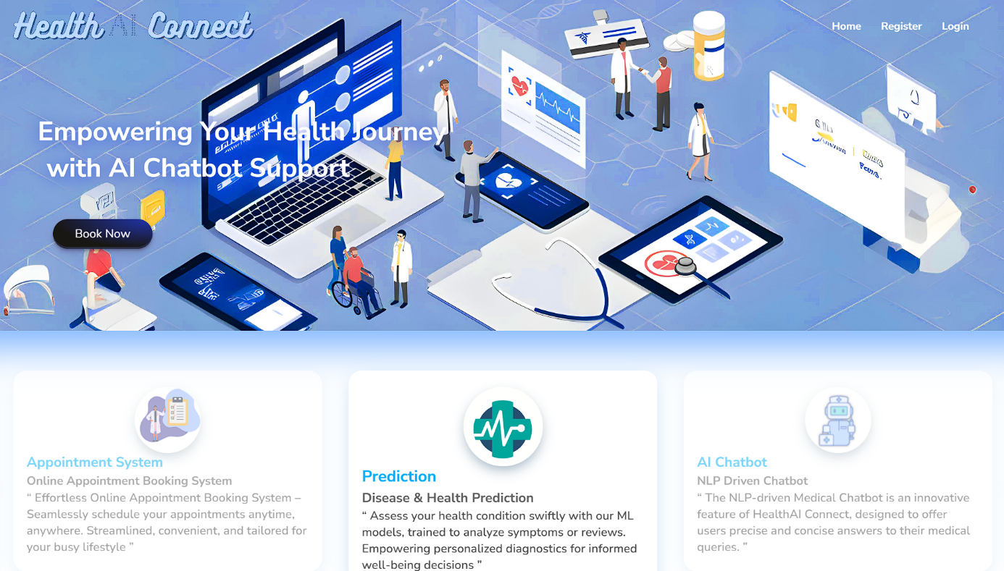**6.SCREENSHOTS**

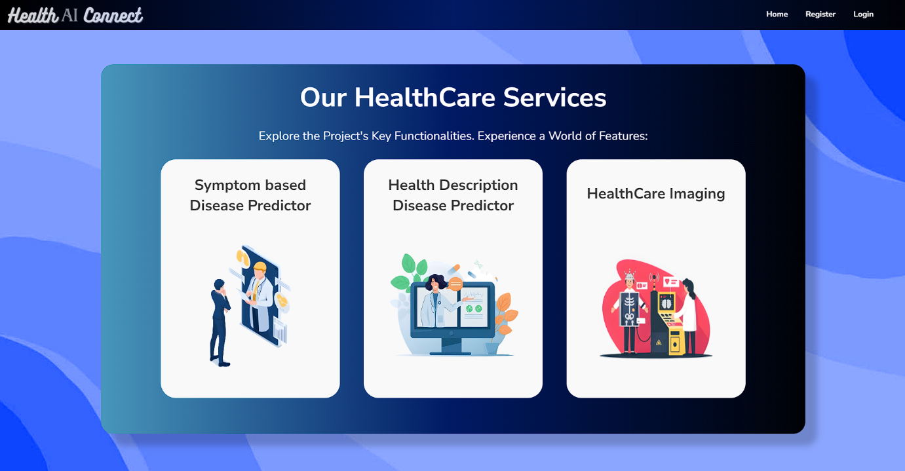Fig 6.1 Homepage

Fig 6.2 Project Feature showcase cards

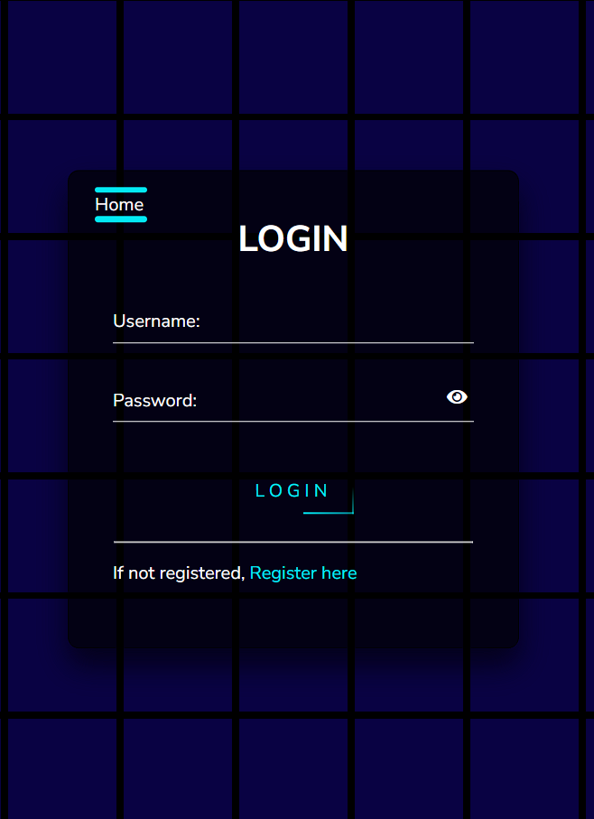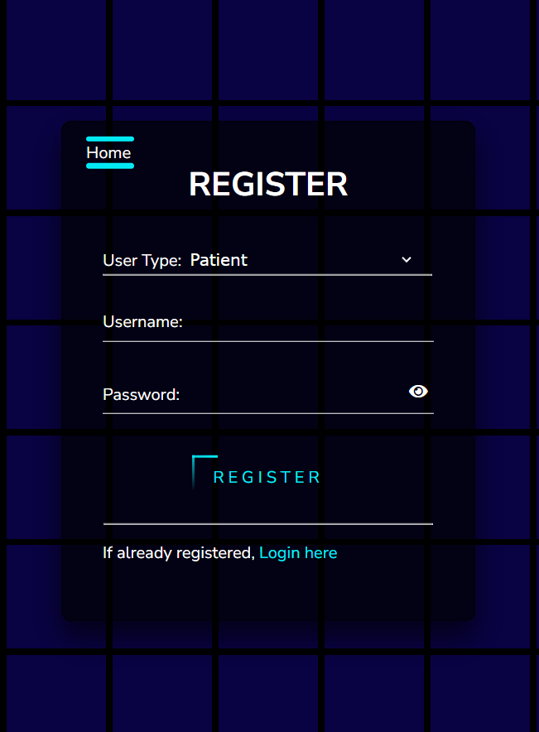Fig 6.3. Register and Login Pages

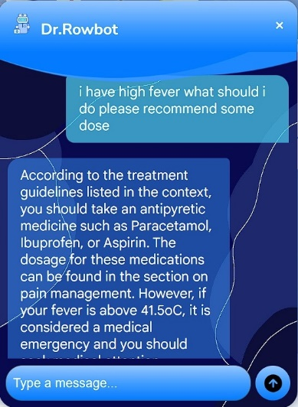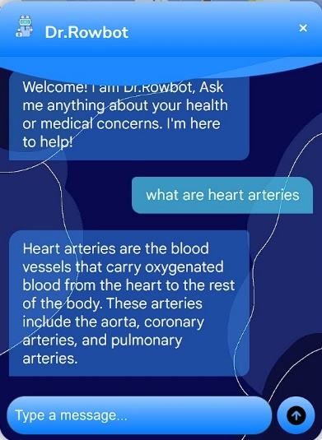Fig 6.4. RAG Medical Chatbot

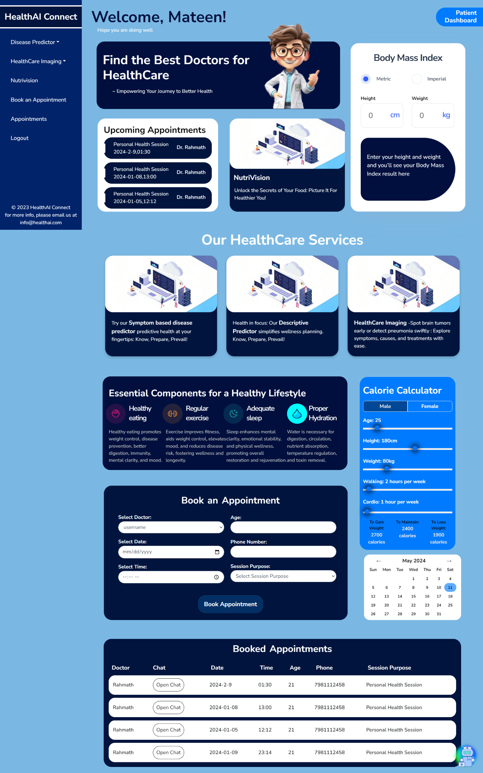Fig 6.5. Patient Dashboard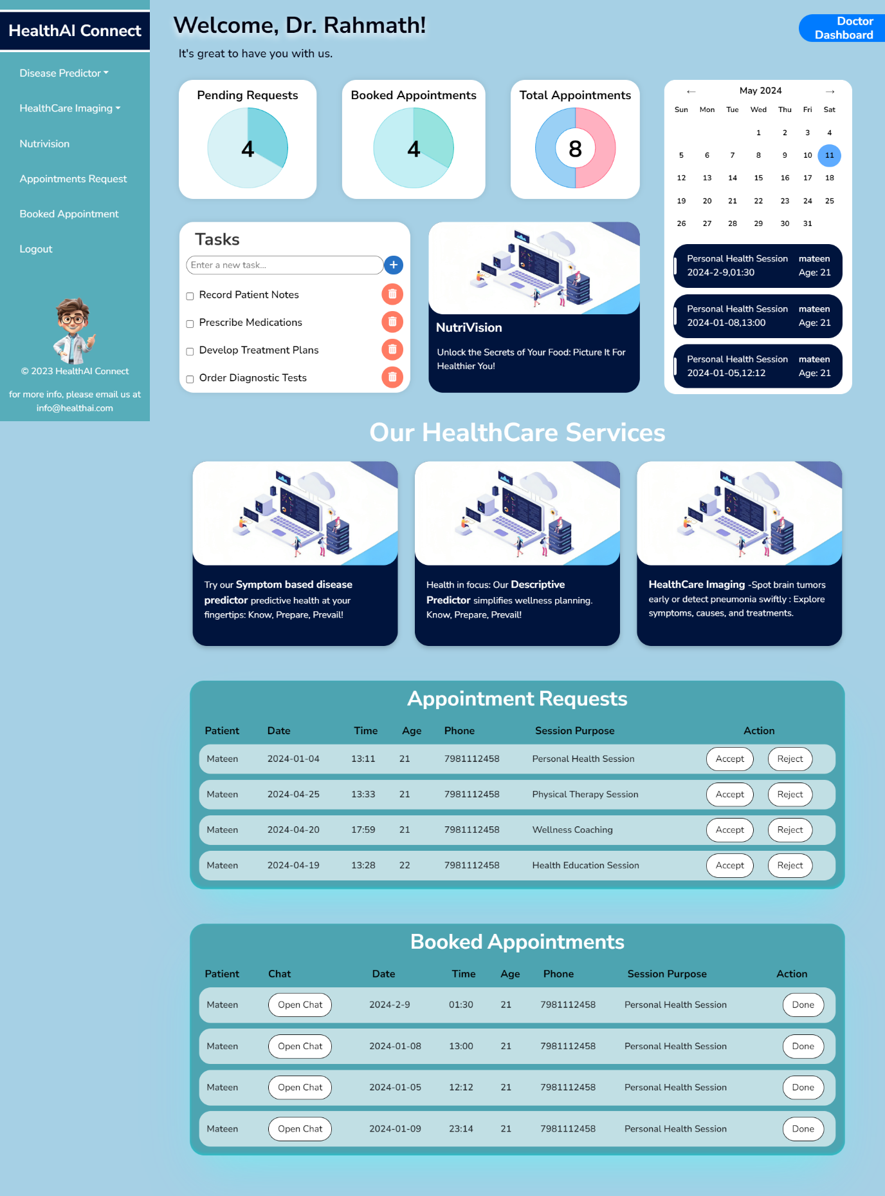

Fig 6.6. Doctor Dashboard

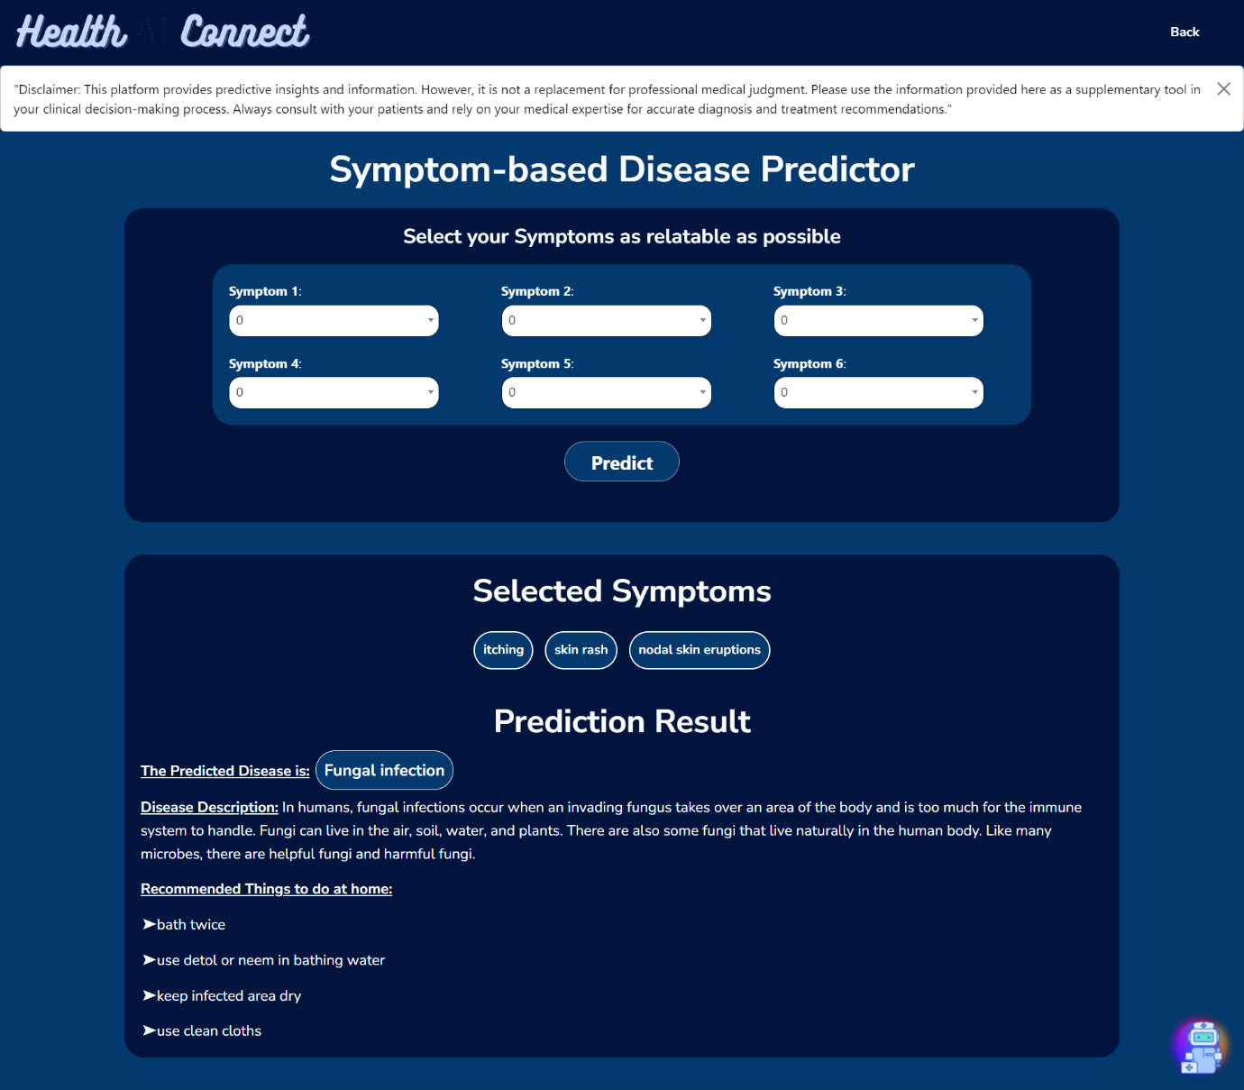

Fig 6.7. Symptoms Based Disease Predictor

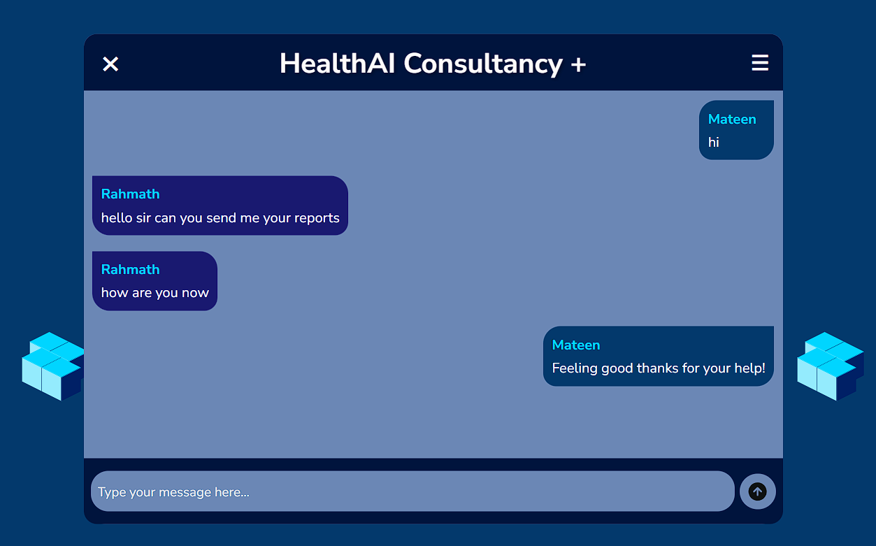

Fig 6.8. Web Chat System

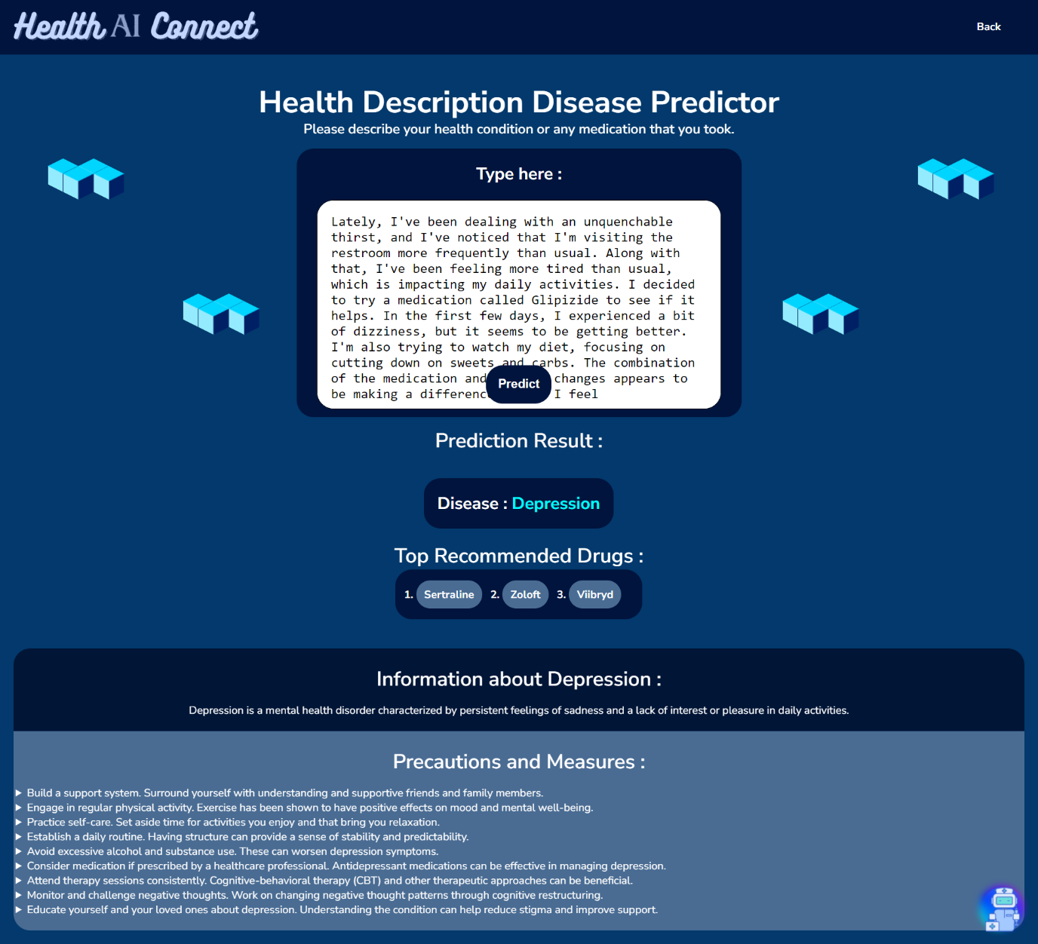

Fig 6.9. Health Condition Description Disease Predictor

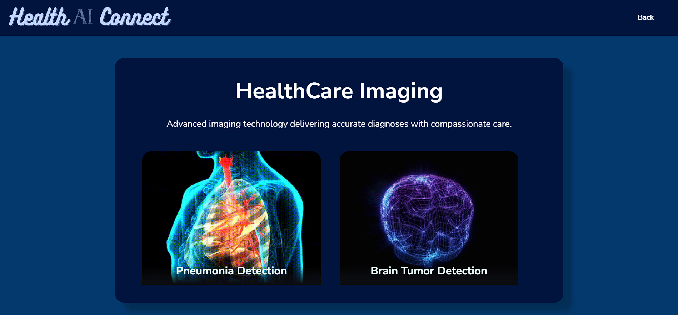

Fig 6.10.Health Imaging Page

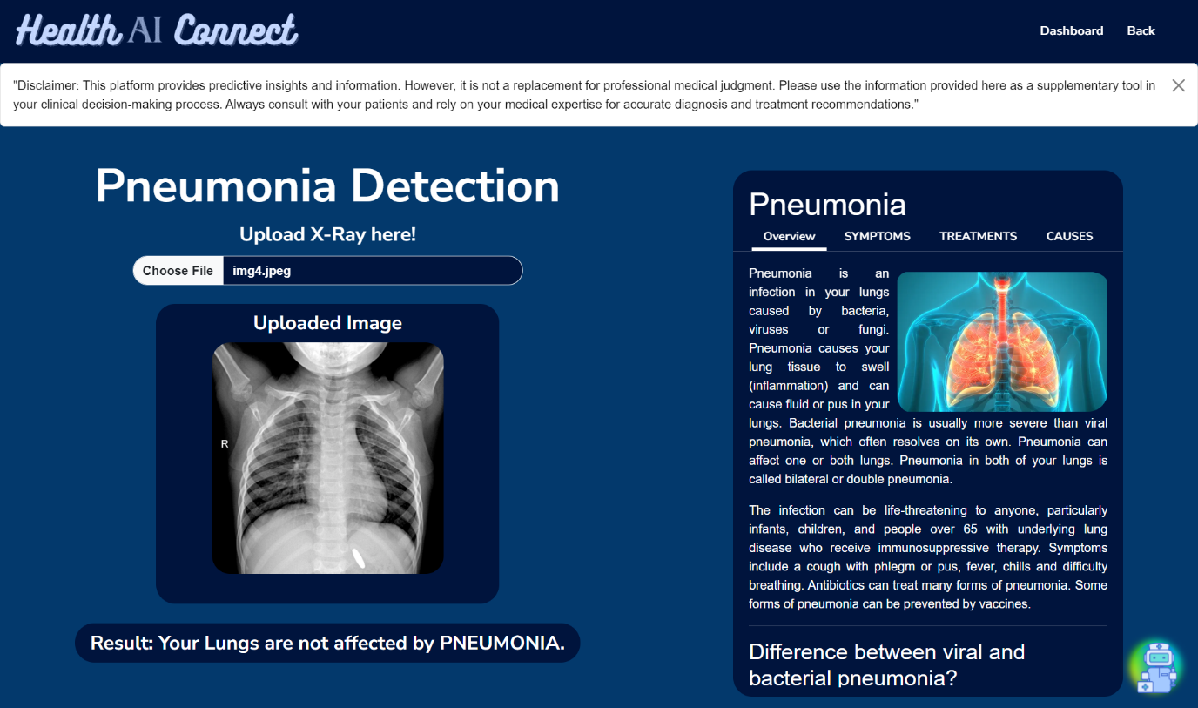

Fig 6.11.(a) Pneumonia Detection Page

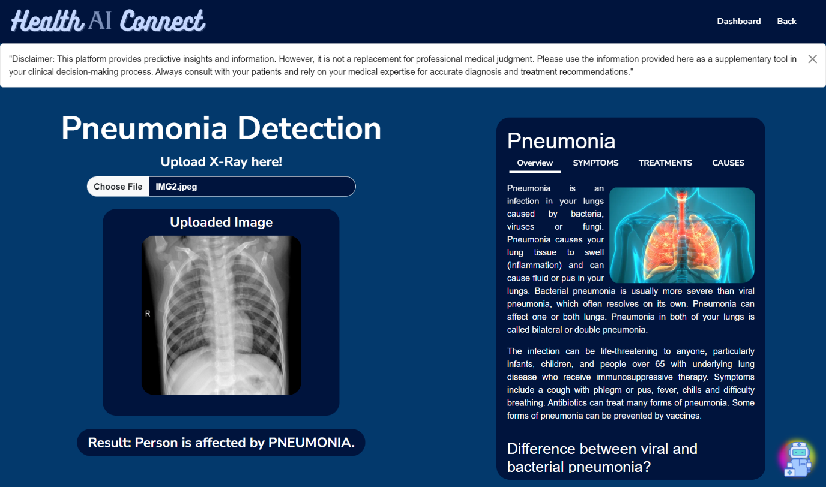

Fig 6.11.(b) Pneumonia Detection Page

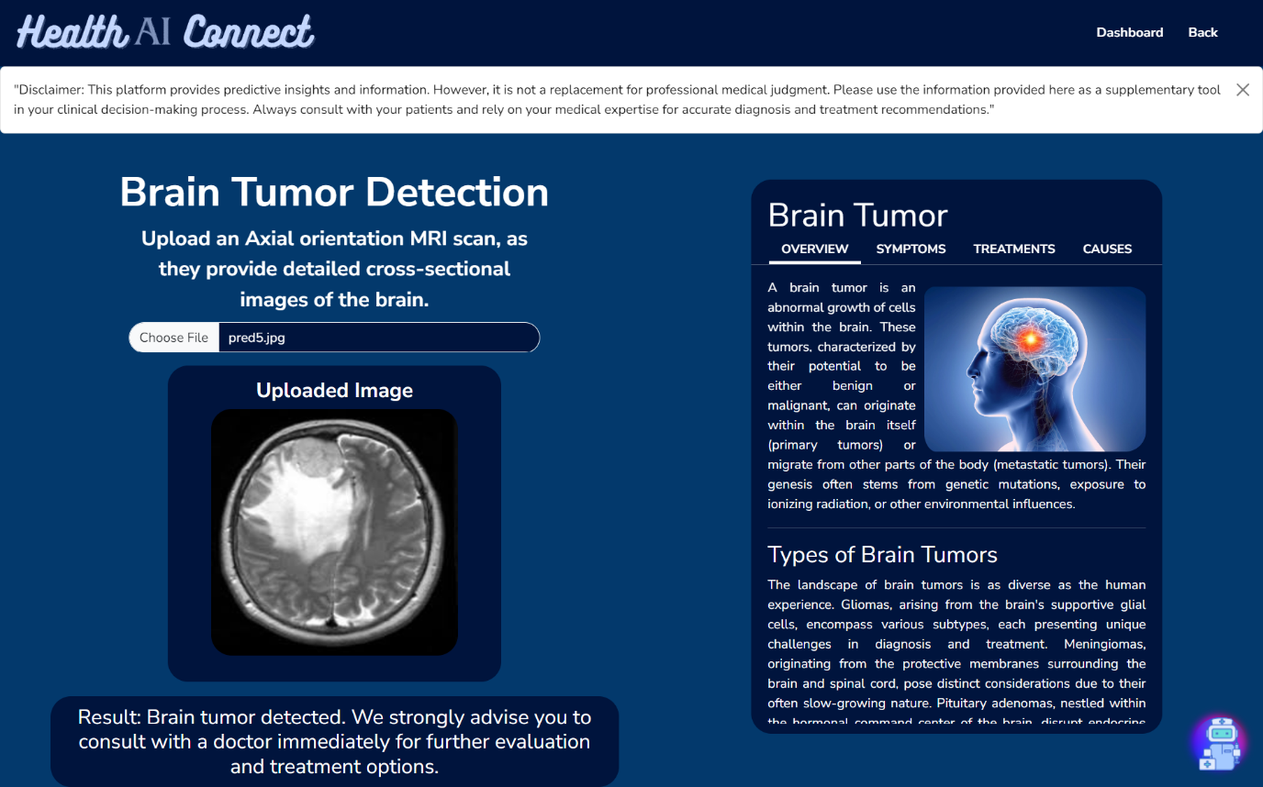

Fig 6.12.(a) Brain Tumor Detection Page

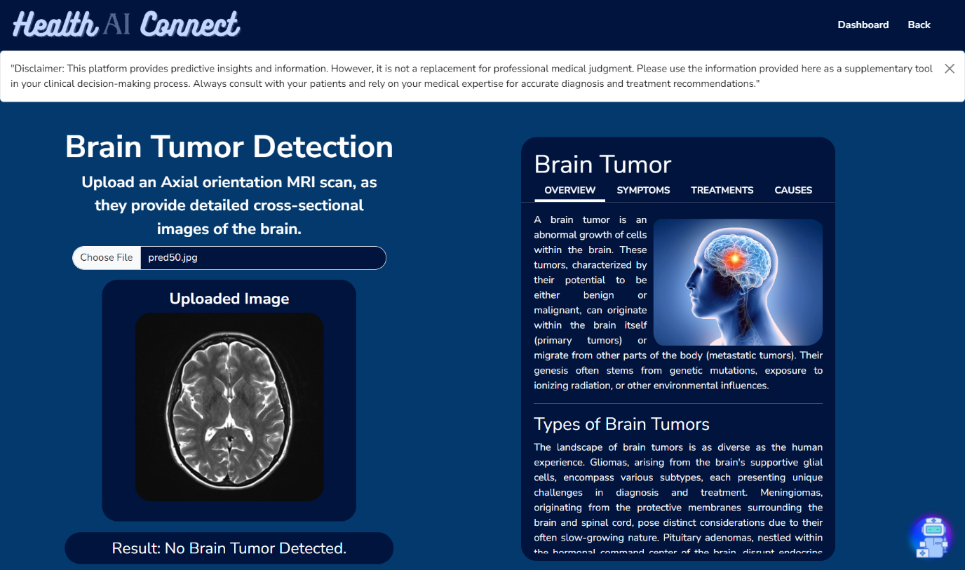

Fig 6.12.(b) Brain Tumor Detection Page

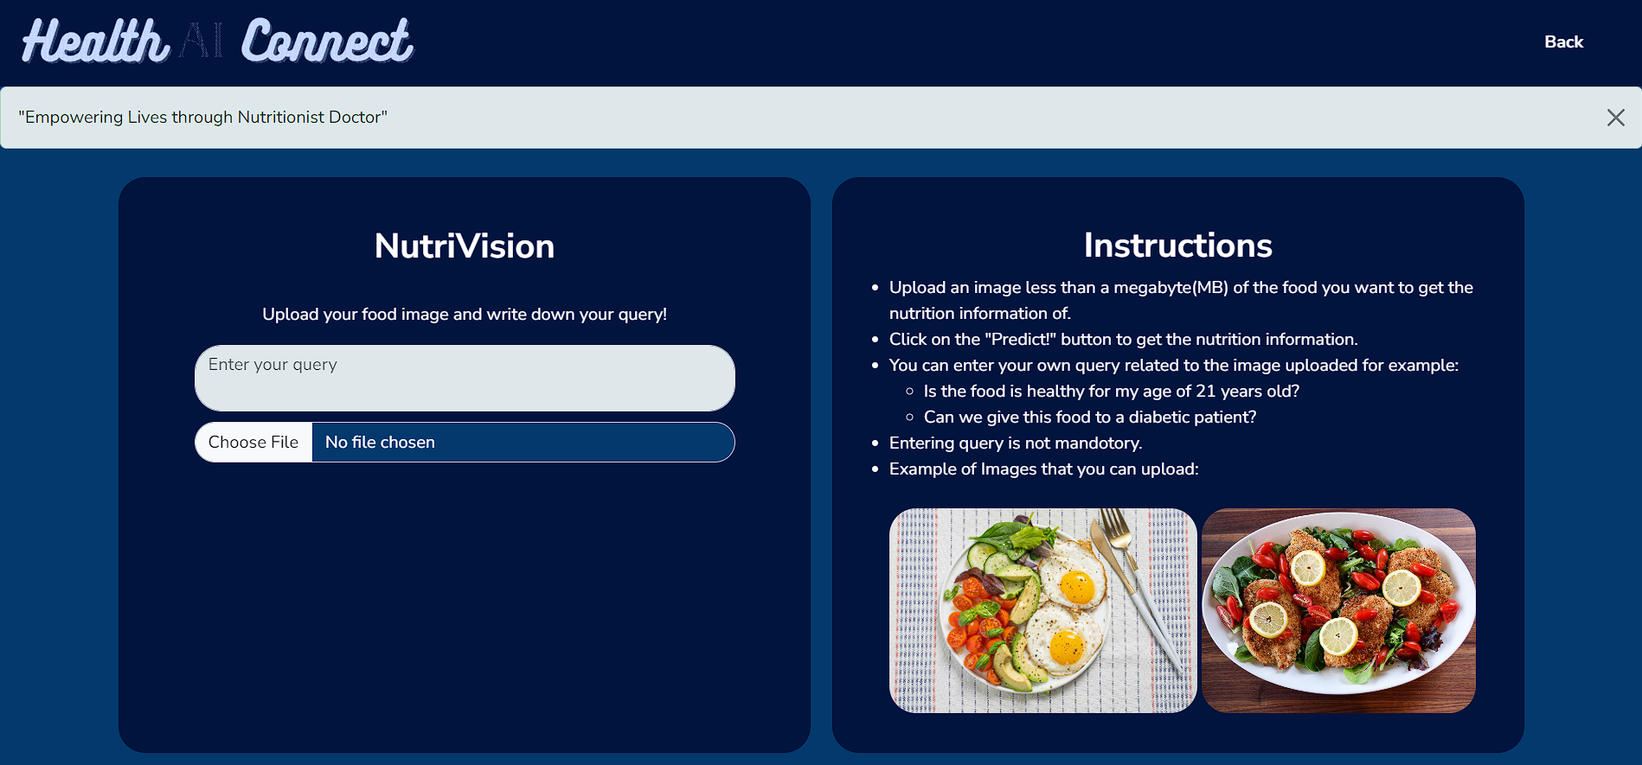

Fig 6.13 (a) NutriVision Page

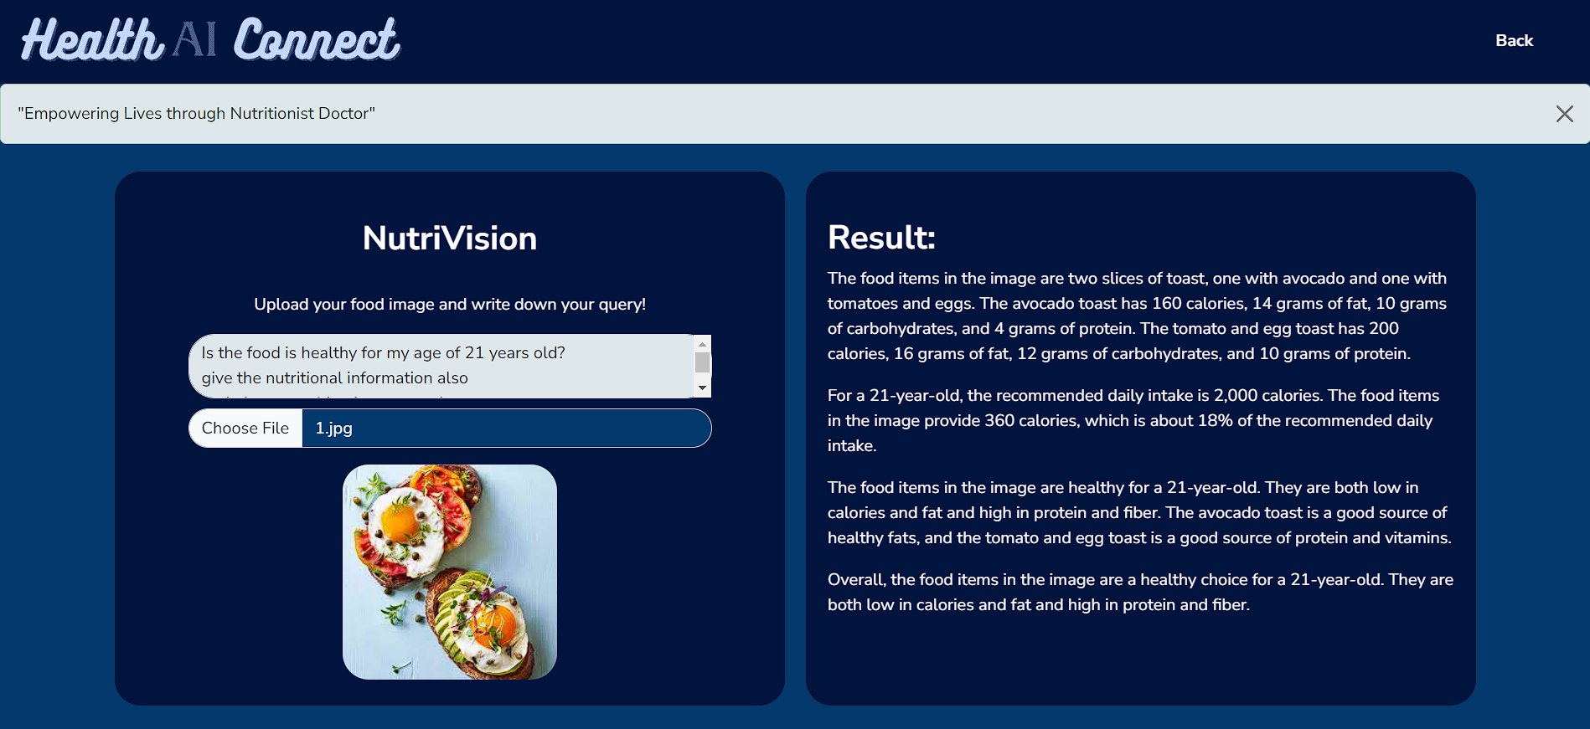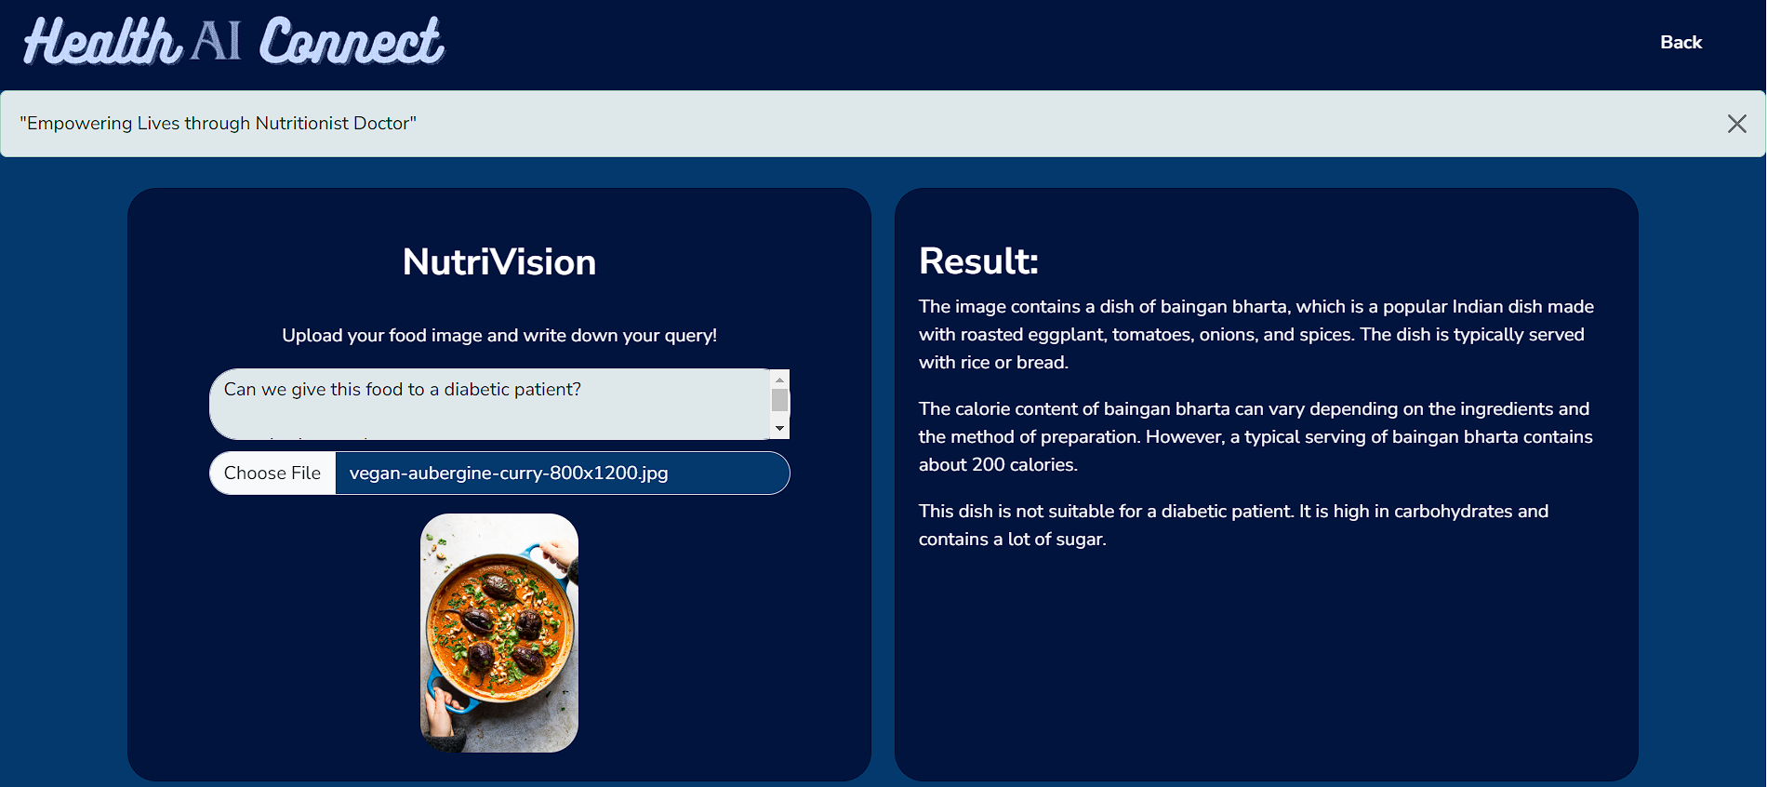

Fig 6.13 (b) NutriVision Results

**7.TEST CASES**

|  |  |  |  |  |
| --- | --- | --- | --- | --- |
| **Test no.** | **Feature Name** | **Input** | **Expected Output** | **Output** |
| 1 | Login | Username, Password | Personalised dashboard | Personalised dashboard |
| 2 | Symptoms based disease predictor | Select Symptoms | Predicted disease, Information & Measures | Predicted disease, Information & Measures |
| 3 | Health description-based disease predictor | Enter Heath description | Predicted Disease, Drugs recommendation, Info, Precautions & Measures | Predicted Disease, Drugs recommendation, Info, Precautions & Measures |
| 4 | Brain Tumor Detection | Upload Brain MRI Scan image | Detect Tumor or  No Tumor | Detect Tumor or  No Tumor |
| 5 | Pneumonia Detection | Upload Chest X-ray image | Detect Pneumonia or  No Pneumonia | Detect Pneumonia or  No Pneumonia |
| 6 | RAG Medical Chatbot | Medical or healthcare related query | Answer to the respective query | Answer to the respective query |
| 7 | NutriVision | Upload Food Image and query related to that food | Calories info of the food and answer to the query | Calories info of the food and answer to the query |
| 8 | Appointment Booking | Select doctor and session purpose, enter time, date, age and phone number | Appointment sent to doctor and doctor will accept or reject it | Appointment sent to doctor and doctor will accept or reject it |

**8.CONCLUSION**

In conclusion, HealthAI Connect emerges as a transformative platform poised to redefine healthcare delivery through the seamless integration of advanced technologies. Through a comprehensive exploration of its key features, including disease prediction, innovative medical chatbot, and cutting-edge diagnostic tools like Brain Tumor and Pneumonia Detection, HealthAI Connect showcases the immense potential of artificial intelligence (AI) to revolutionize patient care and diagnostic accuracy in the healthcare sector. The platform's ability to predict diseases based on health condition descriptions and symptoms exemplifies its proactive approach to healthcare, enabling early intervention and optimized treatment pathways. Furthermore, the introduction of the RAG Medical Chatbot represents a significant step forward in patient engagement and support. Through natural language processing and intelligent conversation capabilities, the chatbot provides users with accessible and user-friendly access to healthcare information, fostering informed decision-making and patient empowerment.

These tools not only streamline the diagnostic process but also enhance accuracy and facilitate timely interventions, ultimately improving patient outcomes and reducing healthcare burdens. Despite the remarkable advancements achieved, it is crucial to acknowledge the inherent limitations and challenges associated with AI-driven healthcare solutions. One notable limitation lies in the reliance on curated datasets, which may not fully capture the diversity and complexity of real-world medical scenarios. Additionally, the performance of machine learning models may exhibit variability across different populations and healthcare settings, necessitating ongoing validation and refinement efforts.

Looking ahead, future research endeavors could focus on addressing these limitations by incorporating larger and more diverse datasets, thereby enhancing the robustness and generalizability of AI models. Furthermore, the integration of multi-modal data and the exploration of reinforcement learning techniques hold promise for further improving the accuracy and efficiency of healthcare solutions offered by HealthAI Connect. In essence, the ongoing evolution of HealthAI Connect represents a collaborative endeavor to harness the transformative potential of AI in addressing critical healthcare challenges and advancing patient-centered care. Through continued innovation, collaboration, and adaptation to emerging technologies, HealthAI Connect remains at the forefront of driving progress in AI-driven healthcare, ultimately benefiting individuals and communities worldwide.

**9.REFERENCES**

1. M. A. Khadija, A. Aziz and W. Nurharjadmo, "Automating Information Retrieval from Faculty Guidelines: Designing a PDF-Driven Chatbot powered by OpenAI ChatGPT," 2023 International Conference on Computer, Control, Informatics and its Applications (IC3INA), Bandung, Indonesia, 2023, pp. 394-399, doi: 10.1109/IC3INA60834.2023.10285808.
2. A. S, N. R. Rajalakshmi, V. P. P and J. L, "Dynamic NLP Enabled Chatbot for Rural Health Care in India," 2022 Second International Conference on Computer Science, Engineering and Applications (ICCSEA), Gunupur, India, 2022, pp. 1-6, doi: 10.1109/ICCSEA54677.2022.9936389.
3. S. Chakraborty et al., "An AI-Based Medical Chatbot Model for Infectious Disease Prediction," in IEEE Access, vol. 10, pp. 128469-128483, 2022, doi: 10.1109/ACCESS.2022.3227208.
4. M. Ehghaghi, P. -Y. Zhou, W. Y. Cheng, S. Rajabi, C. -H. Kuo and E. -S. A. Lee, "Interpretable Disease Prediction from Clinical Text by Leveraging Pattern Disentanglement," 2023 IEEE EMBS International Conference on Biomedical and Health Informatics (BHI), Pittsburgh, PA, USA, 2023, pp. 1-7, doi: 10.1109/BHI58575.2023.10313408.
5. Luo, Xiao et al. “A Deep Language Model for Symptom Extraction from Clinical Text and its Application to Extract COVID-19 Symptoms from Social Media.” IEEE journal of biomedical and health informatics vol. 26,4 (2022): 1737-1748. doi:10.1109/JBHI.2021.3123192
6. S. Usharani, S. Prithivi, S. Sharmila, P. M. Bala, T. Ananth Kumar and R. Rajmohan, "Mobile Application for Doctor Appointment Scheduling," 2021 International Conference on System, Computation, Automation and Networking (ICSCAN), Puducherry, India, 2021, pp. 1-6, doi: 10.1109/ICSCAN53069.2021.9526398.
7. U. K. Kommineni, D. P. P. Kowthavarapu, G. S. M. Polukonda and K. C. Yelavarti, "Human Disease Prediction based on Symptoms," 2023 7th International Conference on Computing Methodologies and Communication (ICCMC), Erode, India, 2023, pp. 677-682, doi: 10.1109/ICCMC56507.2023.10083702.
8. P. Hema, N. Sunny, R. Venkata Naganjani and A. Darbha, "Disease Prediction using Symptoms based on Machine Learning Algorithms," 2022 International Conference on Breakthrough in Heuristics and Reciprocation of Advanced Technologies (BHARAT), Visakhapatnam, India, 2022, pp. 49-54, doi: 10.1109/BHARAT53139.2022.00021.
9. K. S. Kumar, M. Sai Sathya, A. Nadeem and S. Rajesh, "Diseases Prediction based on Symptoms using Database and GUI," 2022 6th International Conference on Computing Methodologies and Communication (ICCMC), Erode, India, 2022, pp. 1353-1357, doi: 10.1109/ICCMC53470.2022.9753707.
10. T. Nag, S. S. Rajawat and A. Rana, "Detection of Pneumonia using Chest X-Ray Images and Convolutional Neural Network," 2021 9th International Conference on Reliability, Infocom Technologies and Optimization (Trends and Future Directions) (ICRITO), Noida, India, 2021, pp. 1-4, doi: 10.1109/ICRITO51393.2021.9596172.
11. N. M. Dipu, S. A. Shohan and K. M. A. Salam, "Deep Learning Based Brain Tumor Detection and Classification," 2021 International Conference on Intelligent Technologies (CONIT), Hubli, India, 2021, pp. 1-6, doi: 10.1109/CONIT51480.2021.9498384.
12. A. Goswami and M. Dixit, "An Analysis of Image Segmentation Methods for Brain Tumour Detection on MRI Images," 2020 IEEE 9th International Conference on Communication Systems and Network Technologies (CSNT), Gwalior, India, 2020, pp. 318-322, doi: 10.1109/CSNT48778.2020.9115791.

**APPENDIX I**

**RELEVANCE OF PROJECT TO POs / PSOs**

|  |  |
| --- | --- |
| **Title of Project** | Enabling Enhanced Patient Care Aided by Artificial Intelligence - HealthAI Connect |
| **Implementation Details** | Python, Html, CSS, JavaScript |
| **Cost (hardware or software cost)** | -NA- |
| **Type (Application, Product, model, Review, etc.)** | Application |

|  |  |  |  |  |  |  |  |  |  |  |  |  |  |
| --- | --- | --- | --- | --- | --- | --- | --- | --- | --- | --- | --- | --- | --- |
| **Mapping with POs and PSOs with Justification** | | | | | | | | | | | | | |
| **Relevance** | PO  1 | PO  2 | PO  3 | PO  4 | PO  5 | PO  6 | PO  7 | PO  8 | PO  9 | PO  10 | PO  11 | PO  12 | PSO  1 |
| 3 | 3 | 3 | 3 | 3 | 3 | 3 | 3 | 3 | 3 | 3 | 3 | 3 |
| **Program**  **Outcomes**  **Justification** | PO1: Engineering Knowledge: SDLC phases are followed in the execution of the project.  PO2: Problem Analysis: The different steps involved in Problem Analysis for formulation of the solution i.e., literature survey and use of fundamental subject knowledge has been followed. We considered the drawbacks of existing projects to develop our project by overcoming them.  PO3: Design/Development of solutions – Existing strategy has been enhanced using the design principles.  PO5: Modern Tool Usage: JUPYTER NOTEBOOK, VSCODE  PO6: The Engineer and Society: Students have developed the project which caters to the needs of the people in the society.  PO7: Environment and Sustainability: The developed project has positive impact on the society.  PO8: Ethics: Students have followed professional ethics during the various stages of Project completion.  PO9: Individual and Team Work: Students have worked both in individual as well as team capacity during the various stages of project work.  PO10: Communication: Effective communication with team members and during project reviews, project seminar and viva-voce has been exhibited.  PO11: Project management and Finance: The understanding of the engineering and management principles were demonstrated and applied to the project, as a member in a team, to manage projects in multidisciplinary environments.  PO12: Lifelong Learning. The project carried out gives the students scope to continue the work in Malware detection area in future. | | | | | | | | | | | | |
| **Program**  **Specific**  **Outcomes**  **Justification** | PSO1: Use of Open-Source Jupyter Notebook, Various Python Libraries, VSCode | | | | | | | | | | | | |

**APPENDIX II**

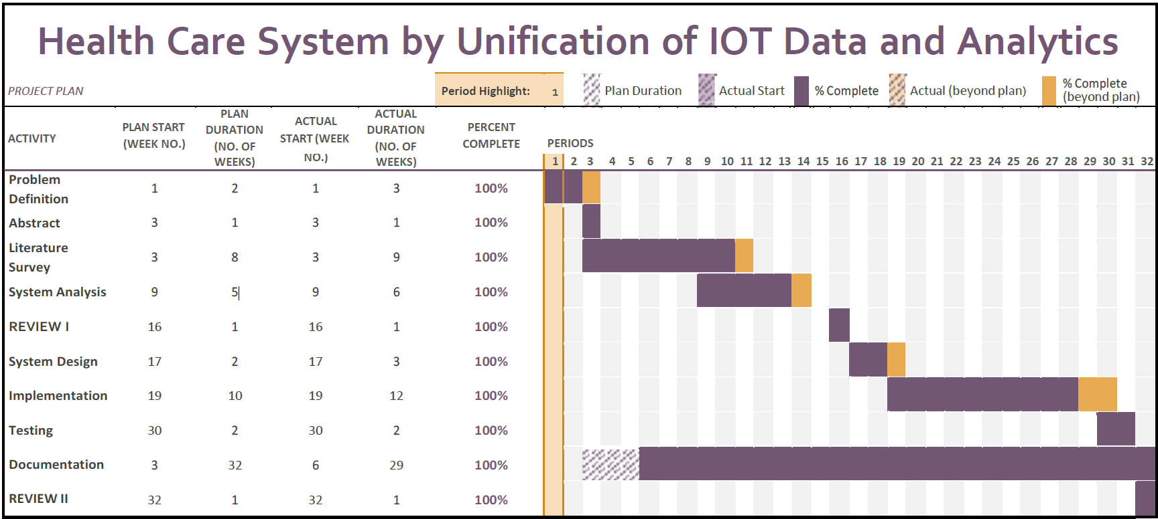**GANTT CHART**

**Enabling Enhanced Patient Care Aided by Artificial Intelligence -HealthAI Connect**